Spring MVC

Here in this section we will cover spring mvc.

What is Spring MVC ?

1. It is a framework for building web applications in java
2. It is based on Model-View-Controller design pattern.
3. It leverages on core spring framework features like IoC and DI.

Process flow in MVC

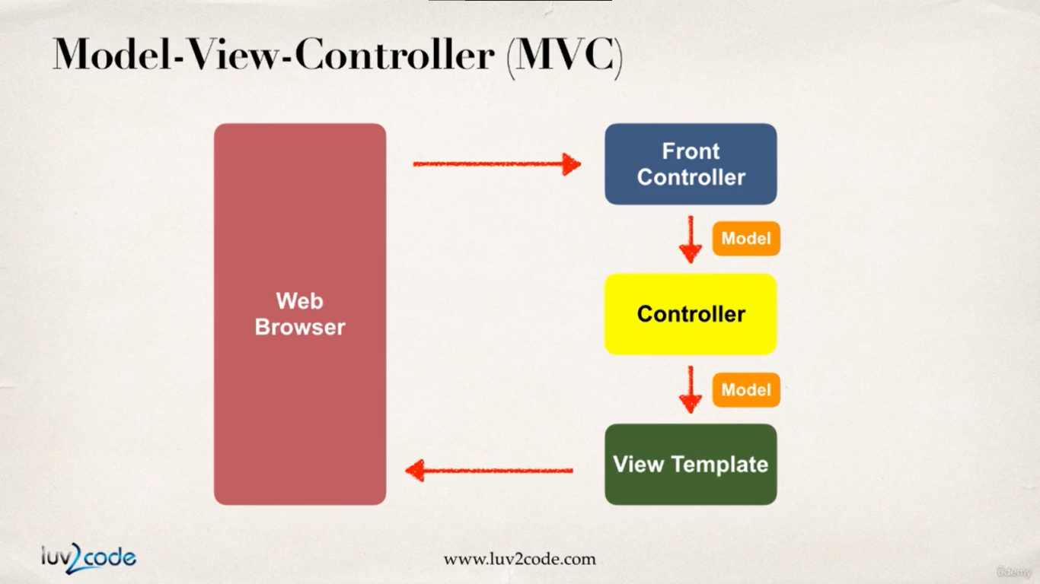

So we have an incoming request coming from the browser which will encounter the spring mvc front controller. This front controller will delegate the request to the controller code.

This controller section contains our business logic. We will also have our model adjusted in this business logic. This model is then passed to the front controller. Now this front controller will pass this model to the view template. View template is basically a HTML or JSP page which will take the model and will render the content to the browser.

We will cover this process of spring dealing with web request in subsequent sections in more detail.

Benefits of using Spring MVC

1. The spring way of building web app UI in java
2. We can create and manage reusable UI components.
3. Helps managing the state for web applications, session tracking and application tracking.
4. We can process and validate the form data.
5. We have flexible configuration for web layer.

Spring MVC behind the scenes

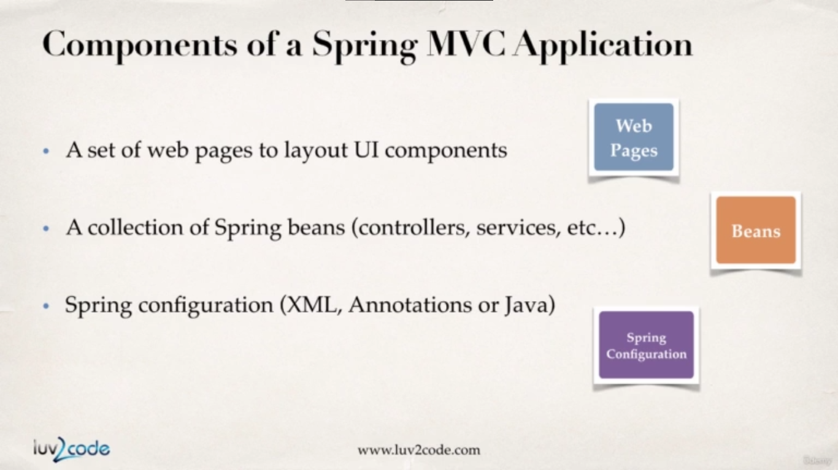

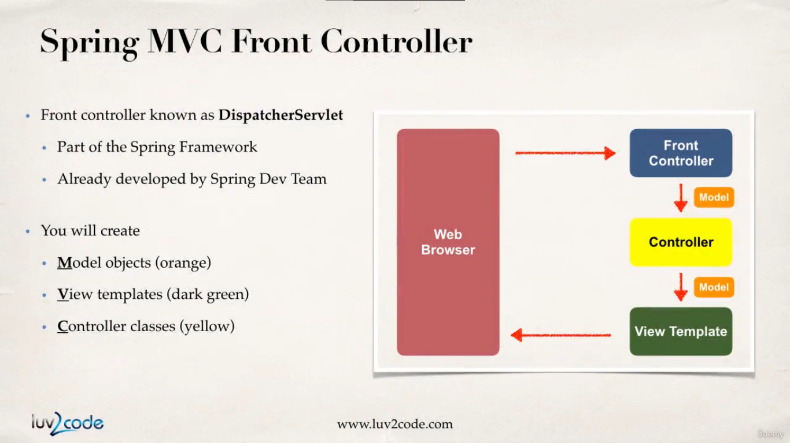

Everything starts with the incoming request and it will encounter something called as the **FrontController.** The FrontController is known as the **DispatcherServlet.** Now this DispatcherServlet is a part of spring framework which we don’t need to develop. This will be available for us to download as a jar.

This FrontController will delegate the request further.

As a developer we need to create the model, view and the controller. In a nutshell the model files will contain the data which will be processed by the controller and will be rendered by view template.

**Controller :**

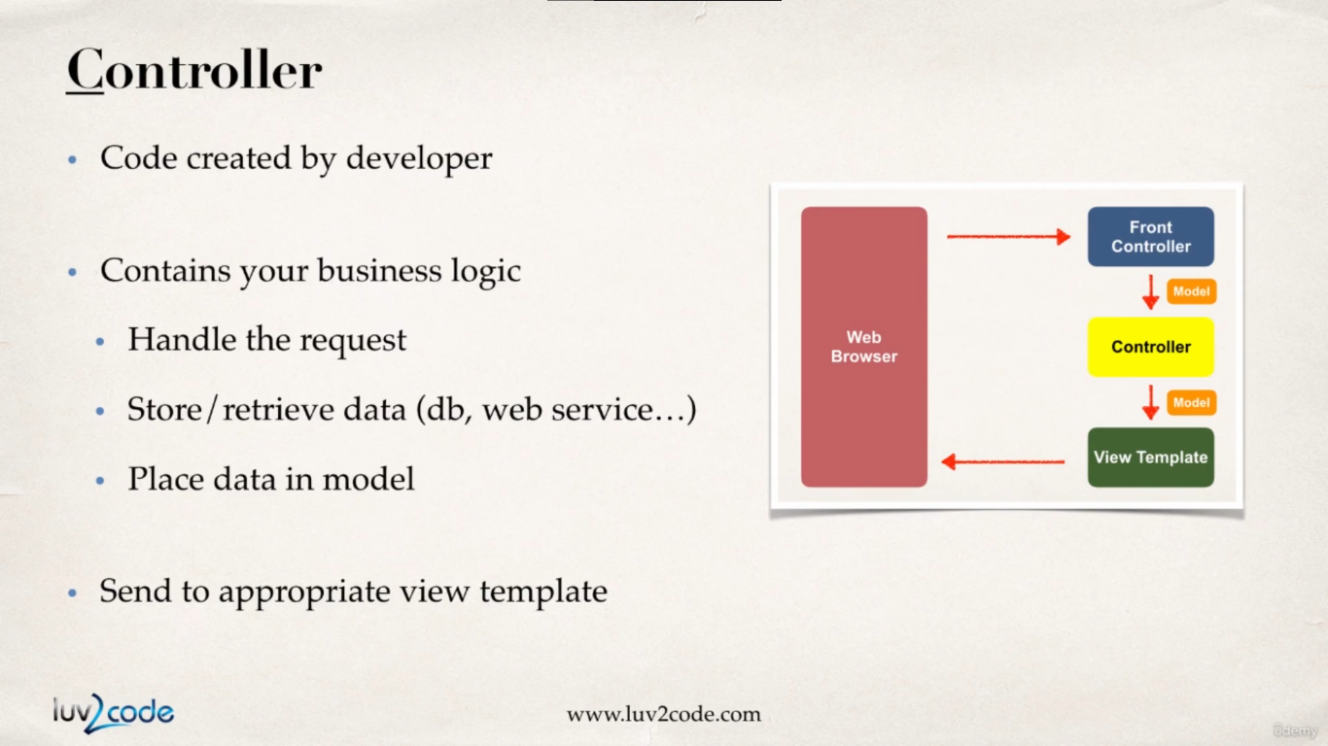

When the request reaches the FrontController it will delegate that request to Controller which will be created by the developer and will contain the business logic.

This controller will have code to handle the incoming request. We might right some logic to read some form data associated with the request and store the data in the models. Also, we can have additional code to perform crud operations with the database or interact with a web server.

Also, the controller will manage the data by putting them inside model files. Controller also takes the responsibility of sending proper model data to the proper view template so they get rendered properly.

**Model :**

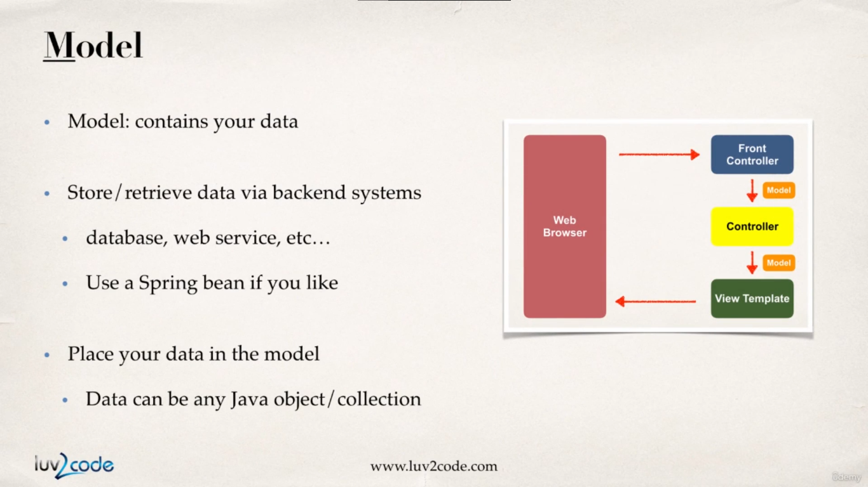

The model will contain our data. Models can also contain data resulting from data base operations and once we have the data then can be shipped to particular View Template for rendering. This model data can either be simple java object or collection.

**View Template :**

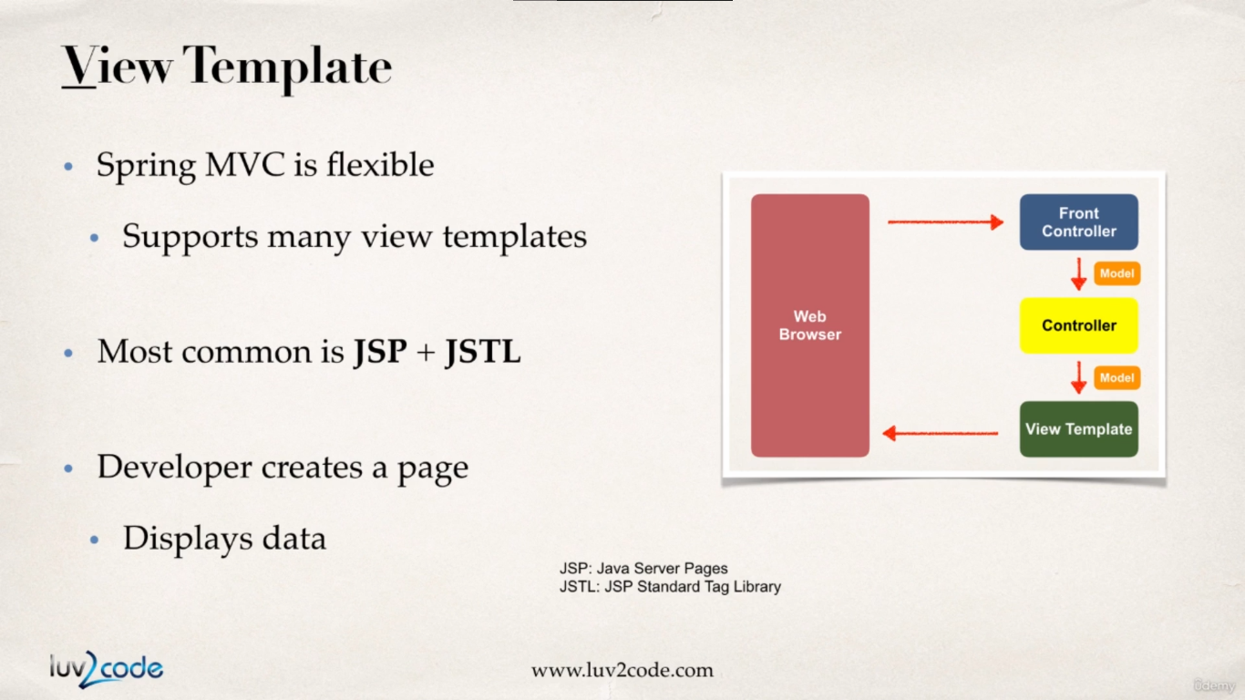

Normally we will have a JSP page where we will display the data from the model into the view template.

Setting up Spring MVC Config

1. Add configurations to the file WEB-INF/web.xml (look point a & b )
   1. **Configure Spring MVC Dispatcher Servlet**

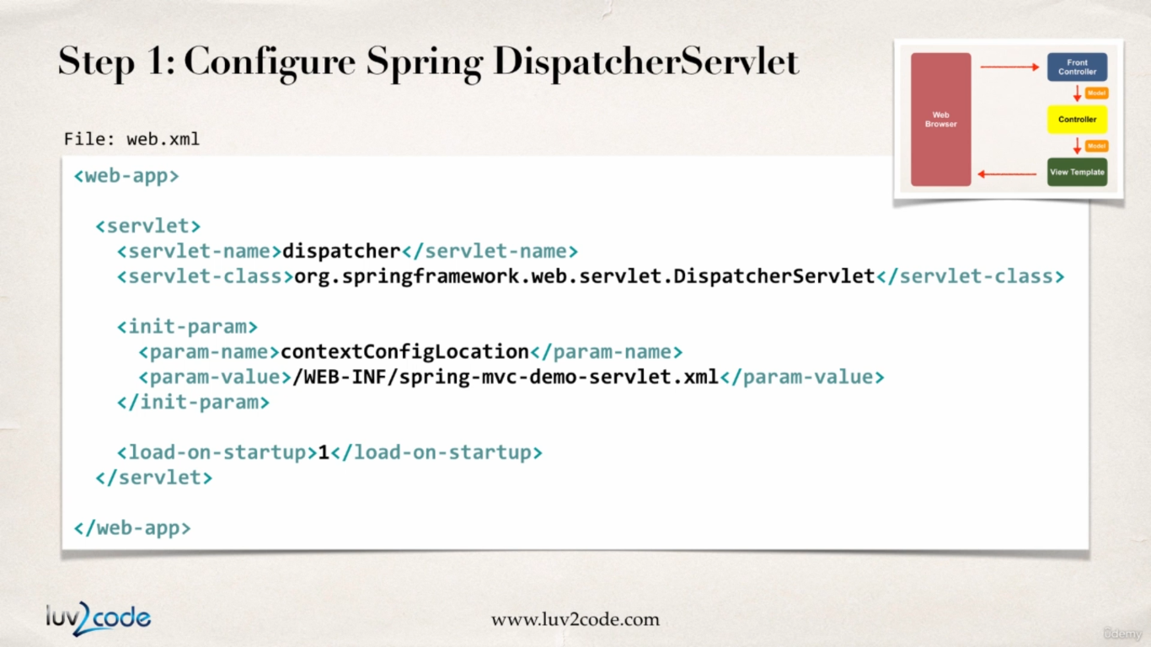

The above config file contains two sections

* Location of the dispatcher servlet, this comes with spring jar so we just need to Provide the qualified **DispatcherServlet** class name as shown below :

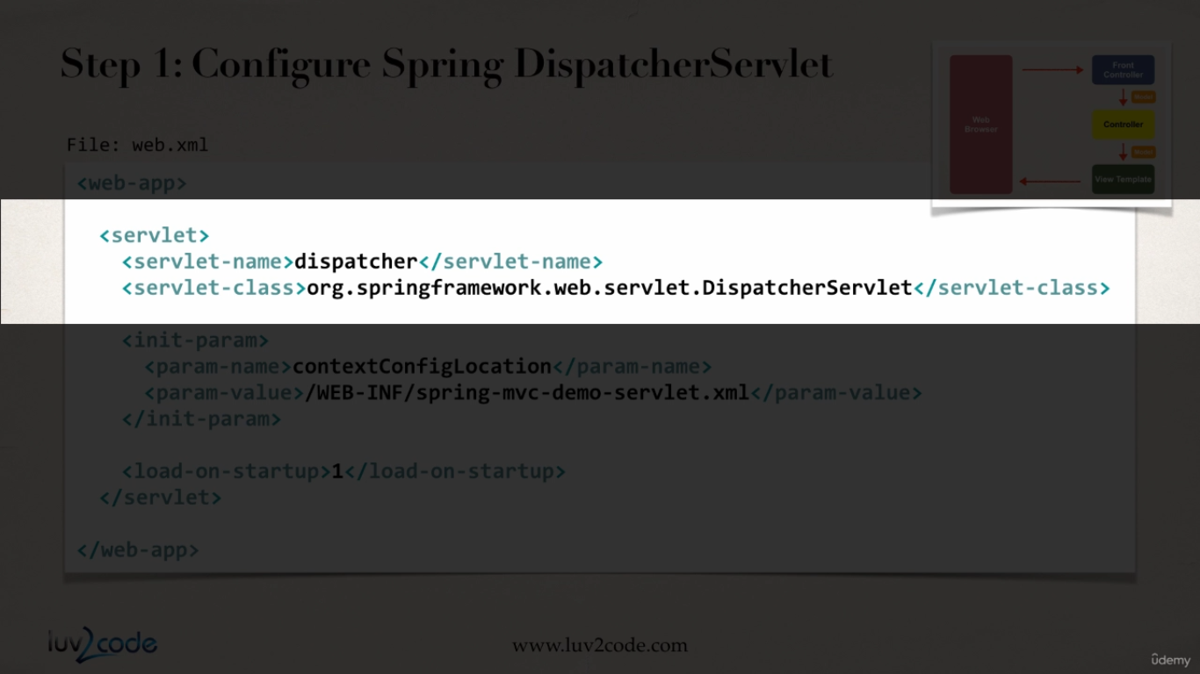

* In the next step as the initial parameter, we specify where the spring context configuration file is located.

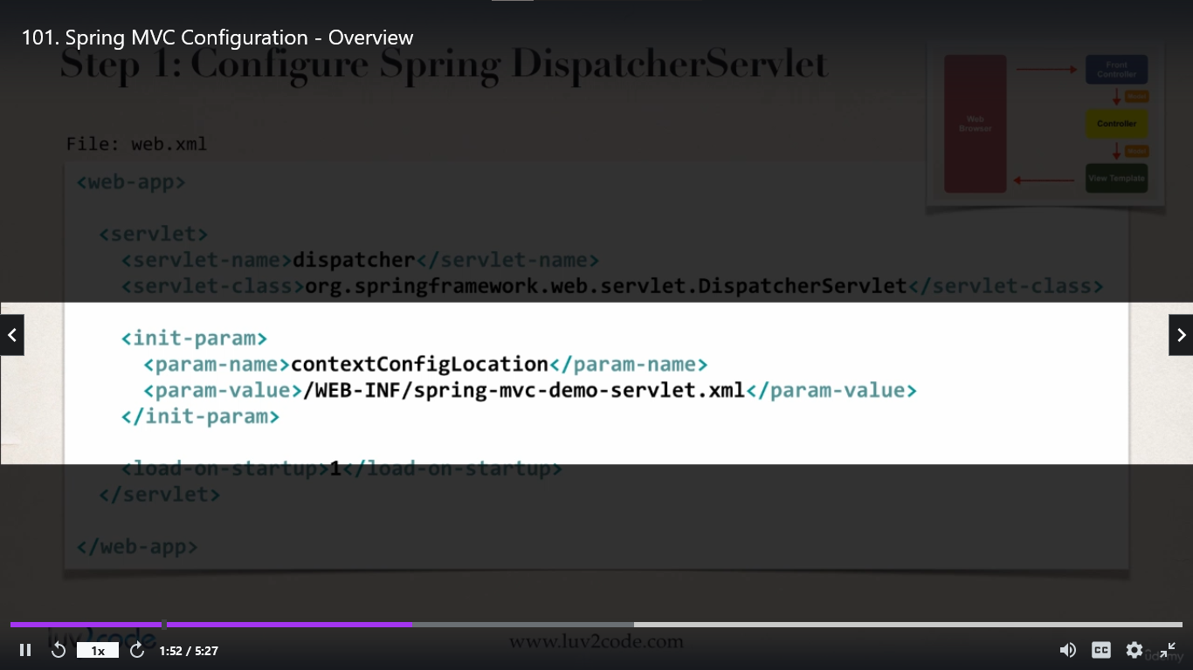

* 1. **Set up url mappings to Spring MVC Dispatcher Servlet**

In this section we just tell our system for any incoming request, the request should be passed on to DispatcherServlet.

By default in here the URL mapping is set to ‘/’ but this can be anything ‘/foo-bar’

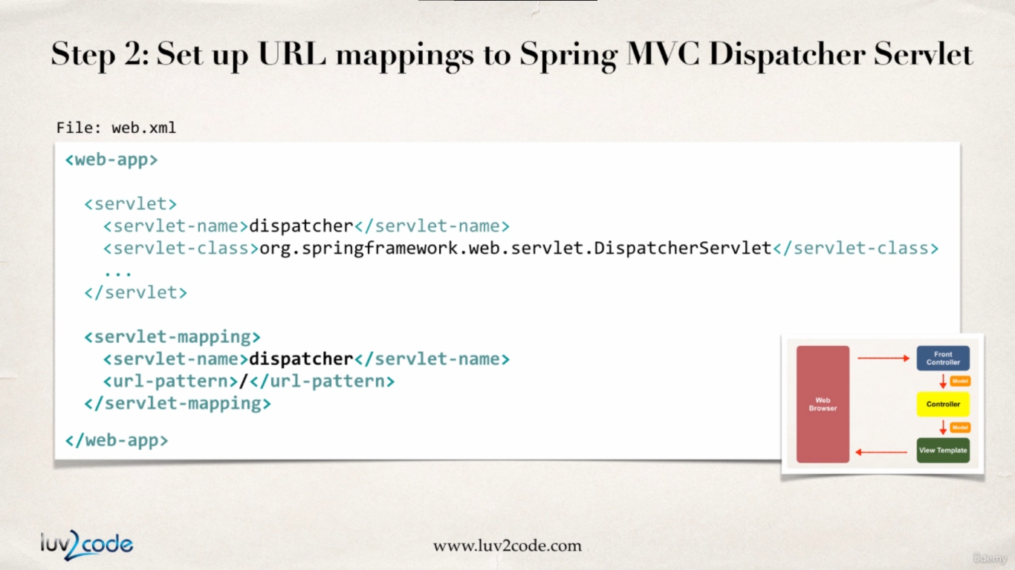

Always remember the servlet-name in the servlet reference and the servlet-name in the servlet-mapping must always match.

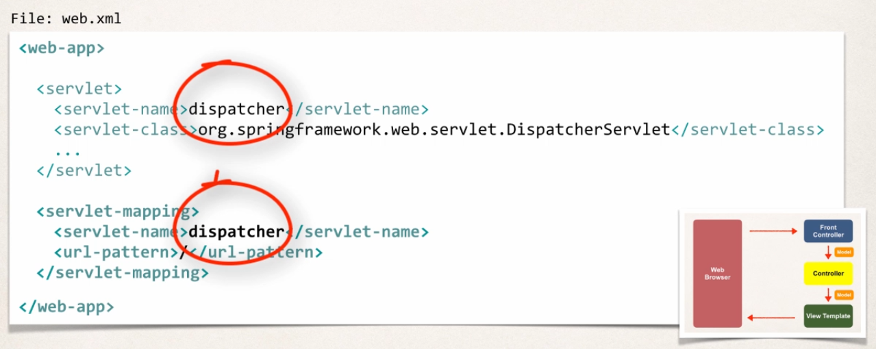

1. Add configurations to the file WEB-INF/spring-mvc-demo-servlet.xml
   1. Add support for component Scanning

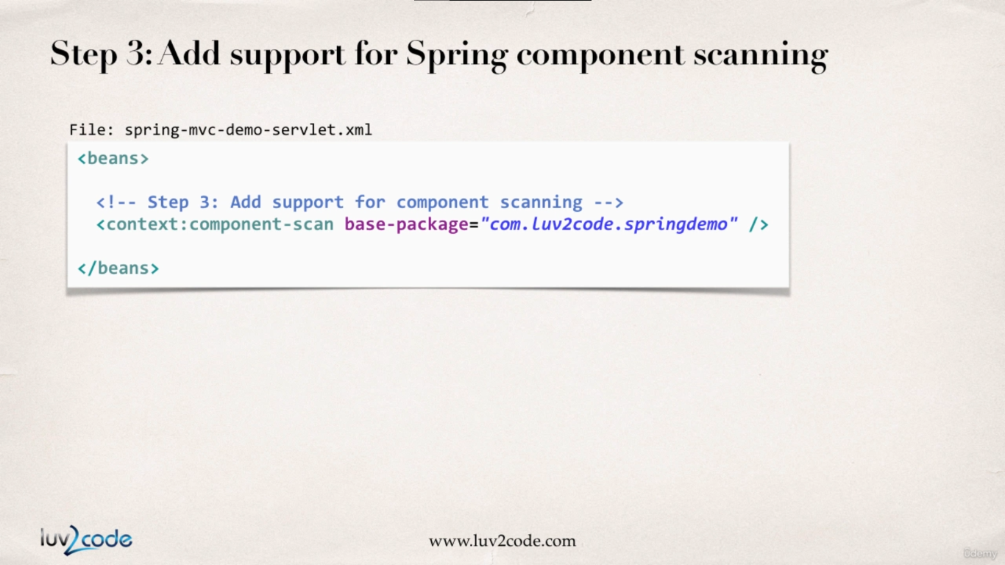

* 1. Add support for conversion, formatting and validation

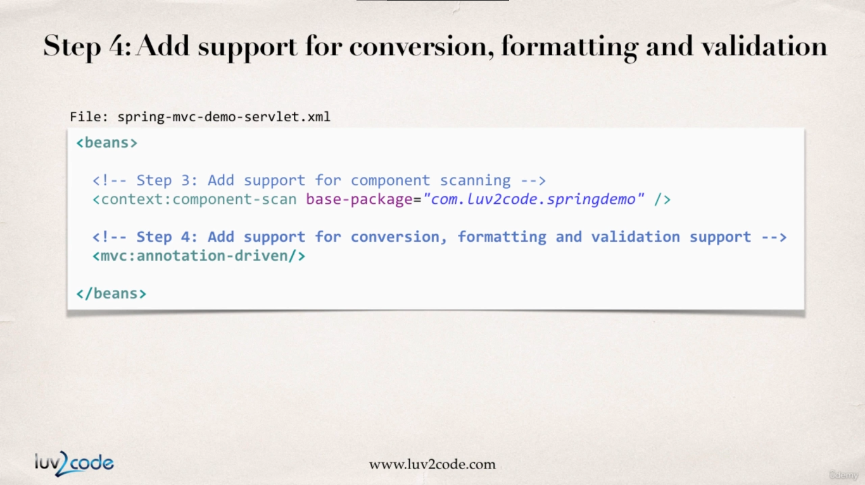

* 1. Configure Spring MVC View Resolver (how do we display the pages or where are the pages located)

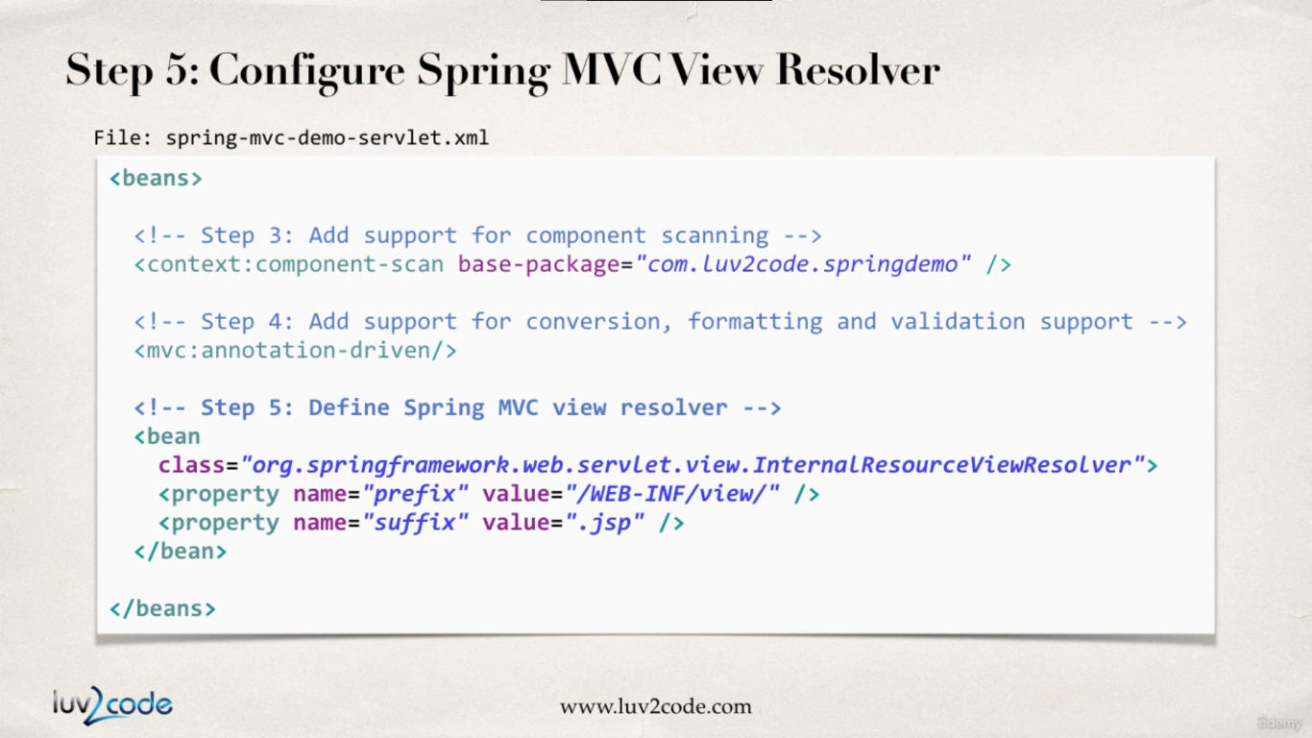

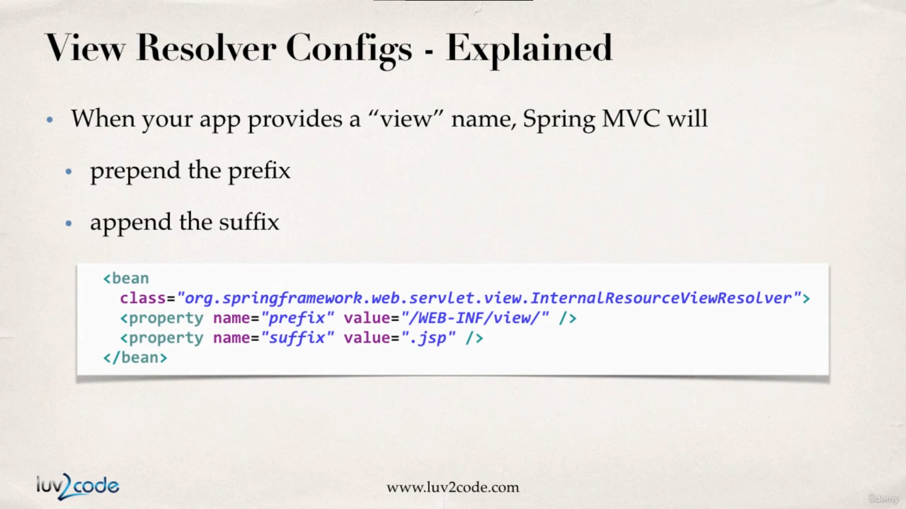

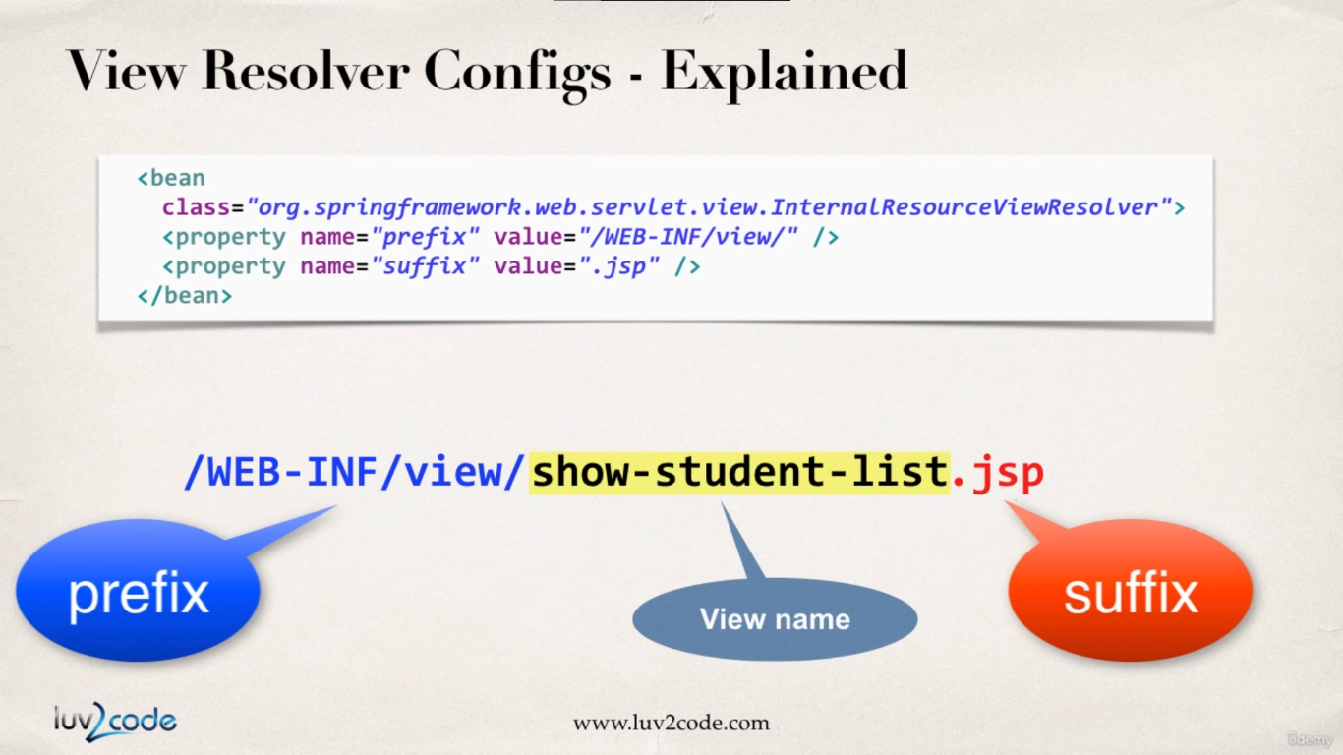

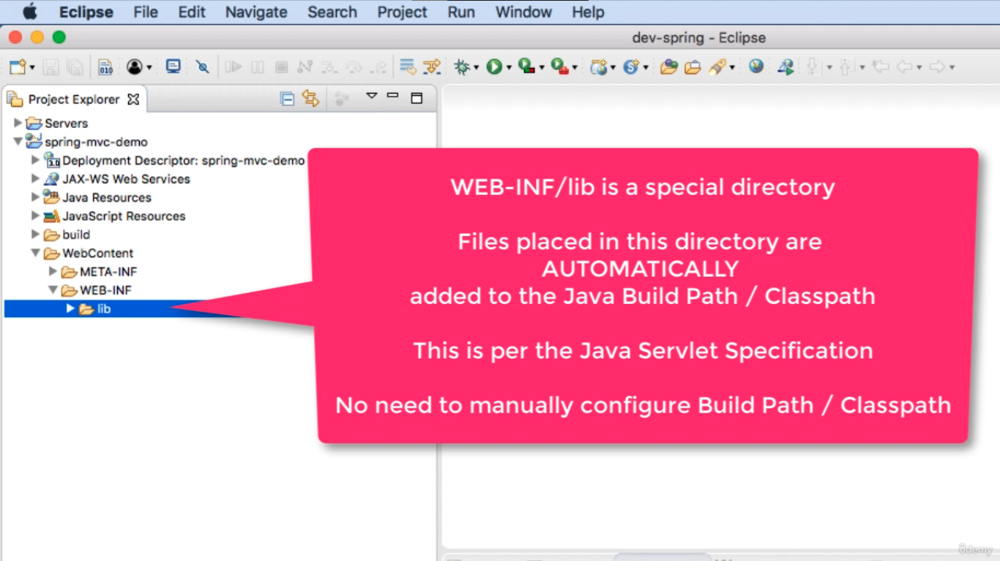

Creating a Spring Home Controller and View :

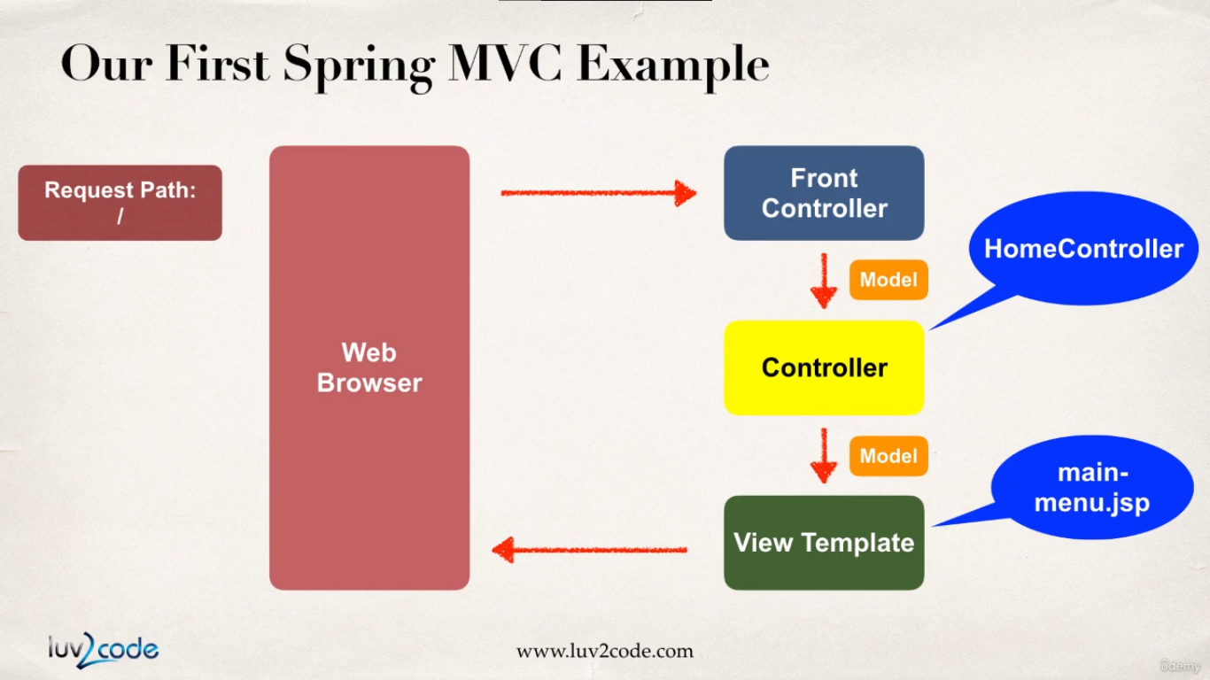

Development Process :

1. Create Controller Class

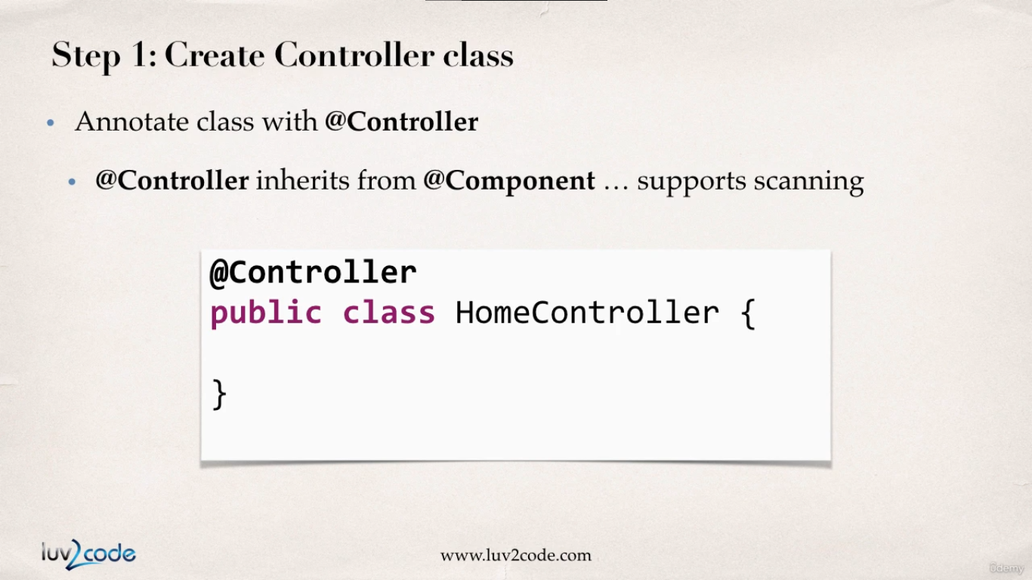

1. Define Controller Method

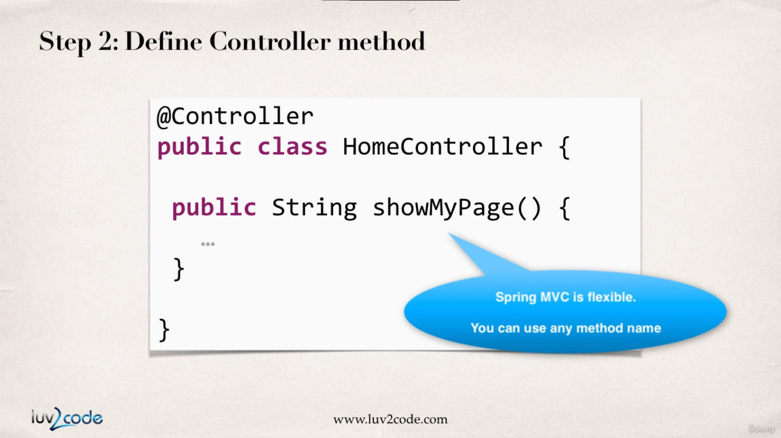

1. Add request mapping to Controller Method

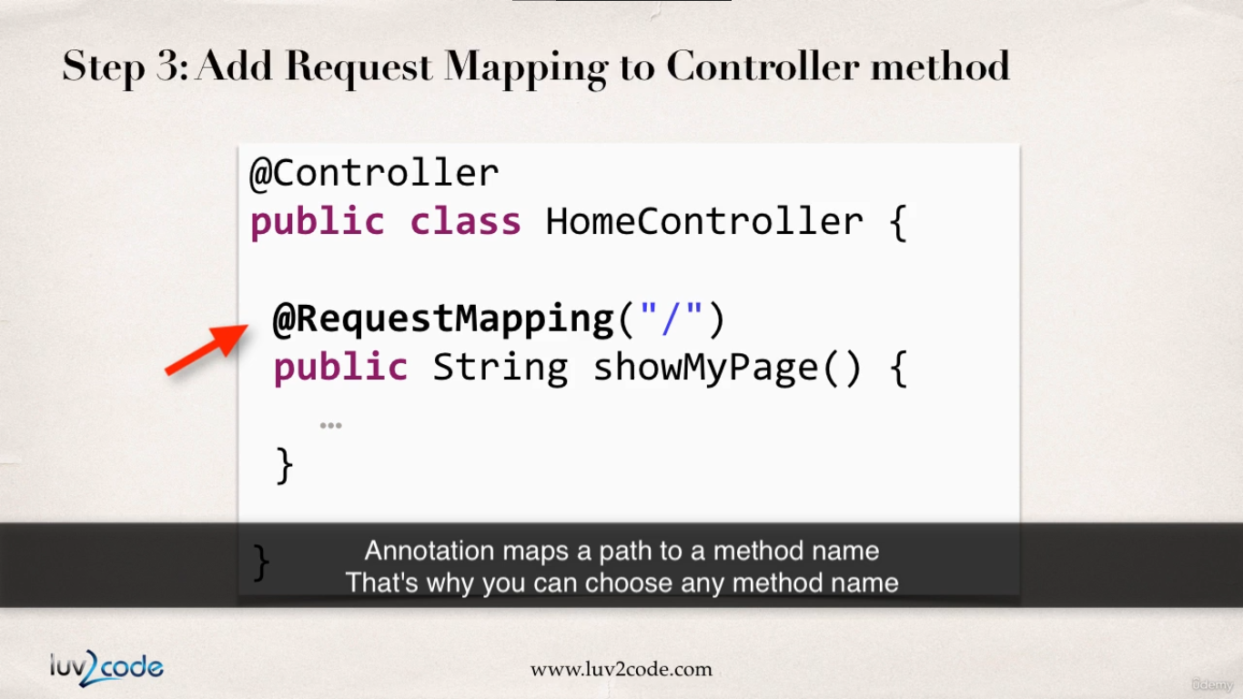

This request mapping will handle all sorts of HTTP requests.

1. Return the View Name

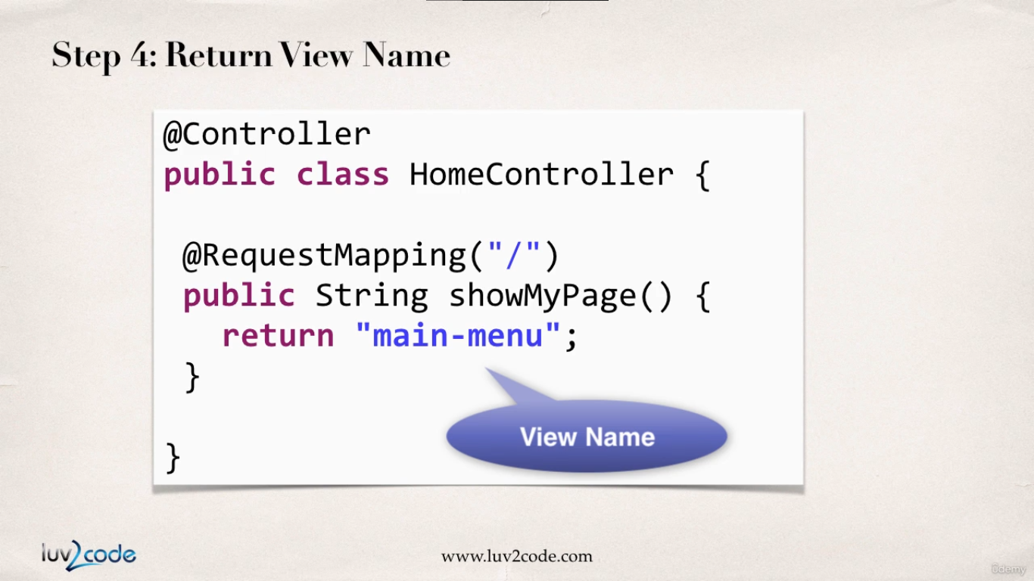

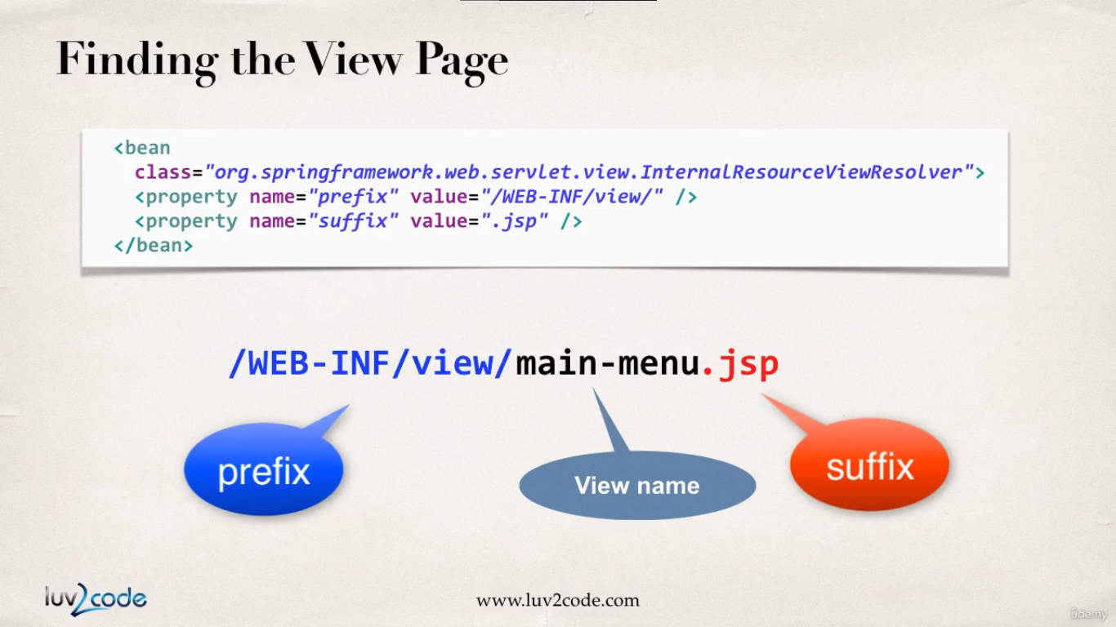

1. Develop the view page.

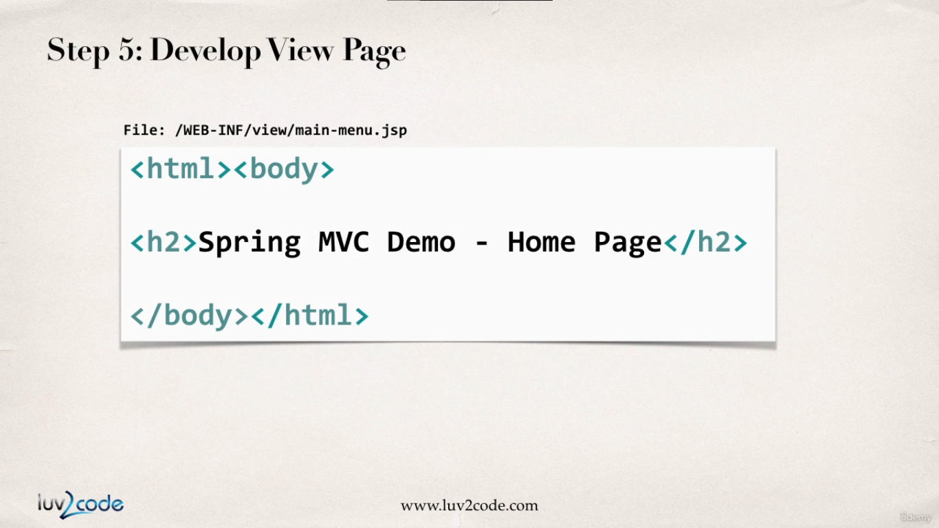

**HomeController.java :**

**package** com.luv2code.springdemo.mvc;

**import** org.springframework.stereotype.Controller;

**import** org.springframework.web.bind.annotation.RequestMapping;

@Controller

**public** **class** HomeController {

@RequestMapping("/")

**public** String showPage() {

**return** "main-menu"; //WEB-INF/view/main-menu.jsp

}

}

**Main-menu.jsp :**

<html>

<head>

<title>Spring MVC HOME Page</title>

</head>

<body>

<h1>Spring MVC HOME Page</h1>

</body>

</html>

**Web.xml :**

<?xml version=*"1.0"* encoding=*"UTF-8"*?>

<web-app xmlns:xsi=*"http://www.w3.org/2001/XMLSchema-instance"*

xmlns=*"http://xmlns.jcp.org/xml/ns/javaee"*

xsi:schemaLocation=*"http://xmlns.jcp.org/xml/ns/javaee http://xmlns.jcp.org/xml/ns/javaee/web-app_3_1.xsd"*

id=*"WebApp_ID"* version=*"3.1"*>

<display-name>spring-mvc-demo</display-name>

<absolute-ordering />

<!-- Spring MVC Configs -->

<!-- Step 1: Configure Spring MVC Dispatcher Servlet -->

<servlet>

<servlet-name>dispatcher</servlet-name>

<servlet-class>org.springframework.web.servlet.DispatcherServlet</servlet-class>

<init-param>

<param-name>contextConfigLocation</param-name>

<param-value>/WEB-INF/spring-mvc-demo-servlet.xml</param-value>

</init-param>

<load-on-startup>1</load-on-startup>

</servlet>

<!-- Step 2: Set up URL mapping for Spring MVC Dispatcher Servlet -->

<servlet-mapping>

<servlet-name>dispatcher</servlet-name>

<url-pattern>/</url-pattern>

</servlet-mapping>

</web-app>

**Spring-mvc-demo-servlet.xml :**

<?xml version=*”1.0”* encoding=*”UTF-8”*?>

<beans xmlns=*”http://www.springframework.org/schema/beans”*

xmlns:xsi=*”http://www.w3.org/2001/XMLSchema-instance”*

xmlns:context=*”http://www.springframework.org/schema/context”*

xmlns:mvc=*”http://www.springframework.org/schema/mvc”*

xsi:schemaLocation=*”*

[*http://www*](http://www)*.springframework.org/schema/beans*

[*http://www*](http://www)*.springframework.org/schema/beans/spring-beans.xsd*

[*http://www*](http://www)*.springframework.org/schema/context*

[*http://www*](http://www)*.springframework.org/schema/context/spring-context.xsd*

[*http://www*](http://www)*.springframework.org/schema/mvc*

[*http://www*](http://www)*.springframework.org/schema/mvc/spring-mvc.xsd”*>

<!—Step 3: Add support for component scanning 🡪

<context:component-scan

base-package=*”com.luv2code.springdemo”* />

<!—Step 4: Add support for conversion, formatting and validation support 🡪

<mvc:annotation-driven />

<!—Step 5: Define Spring MVC view resolver 🡪

<bean

class=*”org.springframework.web.servlet.view.InternalResourceViewResolver”*>

<property name=*”prefix”* value=*”/WEB-INF/view/”* />

<property name=*”suffix”* value=*”.jsp”* />

</bean>

</beans>

Reading Form Data with Spring MVC

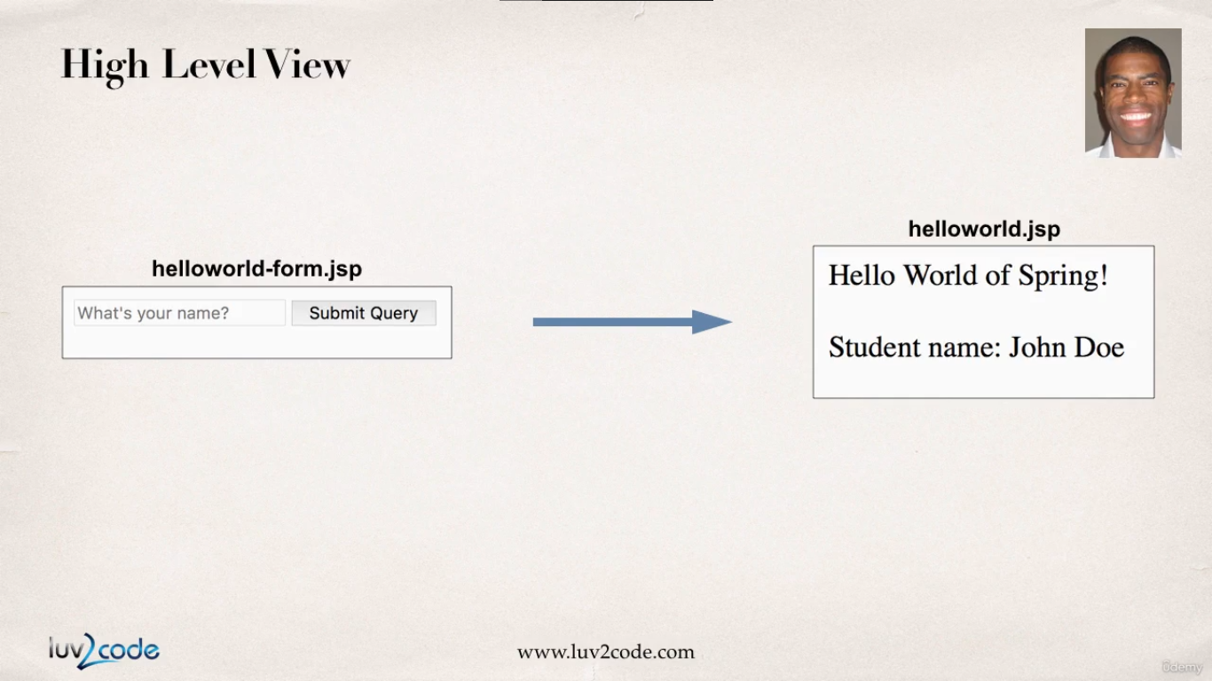

So we will create a form where the user will enter in its name, we will reflect the data in a jsp page.

Development Process :

1. Create Controller Class : HelloWorldController
2. Show HTML form
   1. Create a controller method to show a controller form
   2. Create a view page for HTML form
3. Process HTML form
   1. Create a controller method to process HTML form.
   2. Develop view corresponding page

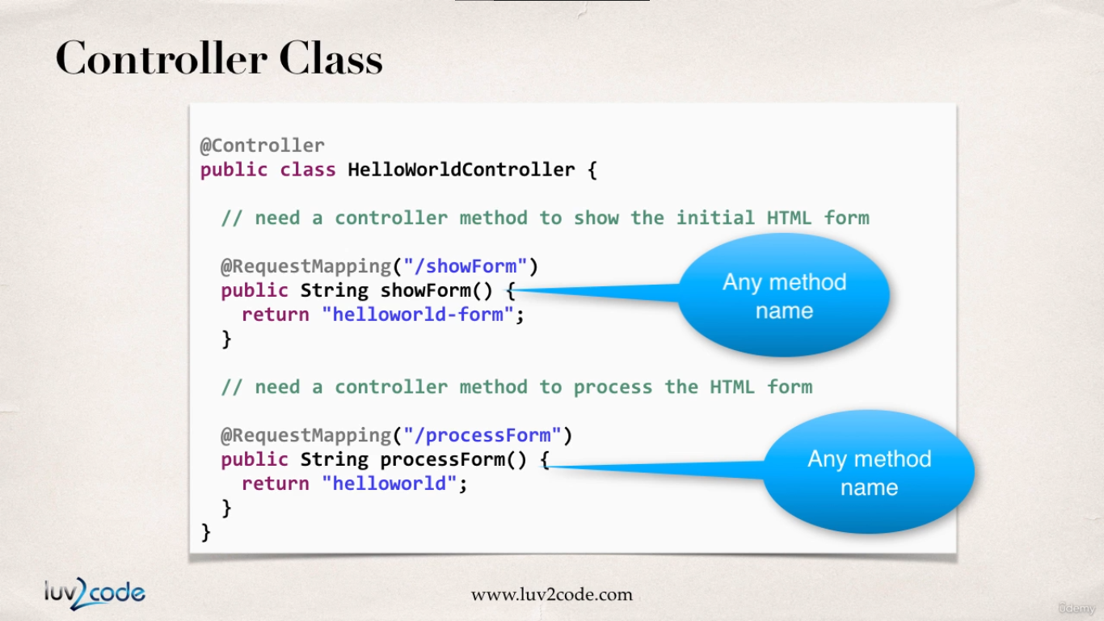

**HelloWorldController.java :**

**package** com.luv2code.springdemo.mvc;

**import** org.springframework.stereotype.Controller;

**import** org.springframework.web.bind.annotation.RequestMapping;

@Controller

**public** **class** HelloWorldController {

// create a controller method to show initial html form

@RequestMapping("/showForm")

**public** String showForm() {

**return** "helloworld-form"; // WEB-INF/view/hellowworld-form.jsp

}

// create a controller method to process the html form

@RequestMapping("/processForm")

**public** String processForm() {

**return** "helloworld";

}

}

**Helloworld-form.jsp**

<!DOCTYPE html>

<html>

<head>

<meta charset=*"ISO-8859-1"*>

<title>Hello World - Input Form</title>

</head>

<body>

<form action=*"processForm"* method=*"get"*>

<input type=*"text"* name=*"studentName"* placeholder=*"what's your name"*>

<input type=*"submit"*>

</form>

</body>

</html>

**Helloworld.jsp :**

<!DOCTYPE html>

<html>

<head>

<meta charset=*"ISO-8859-1"*>

<title>Hello World</title>

</head>

<body>

<h1>Hello World of Spring</h1>

<p>Student name is ${param.studentName}</p>

</body>

</html>

Adding Data to Spring Model

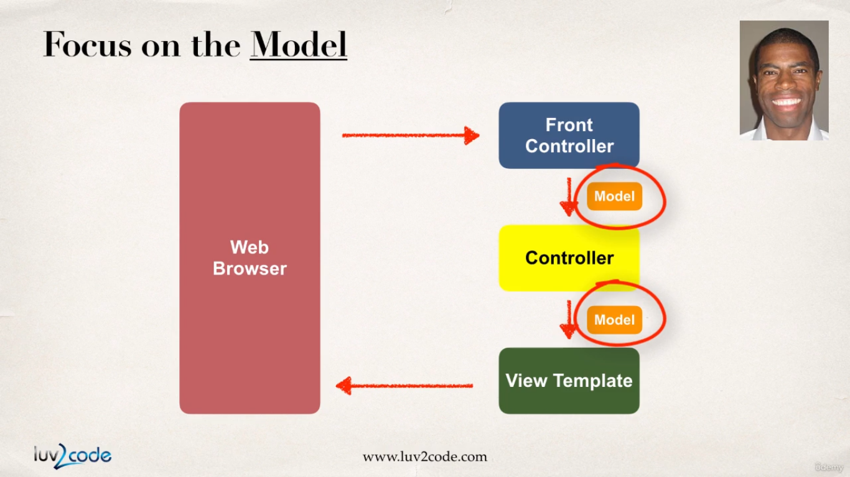

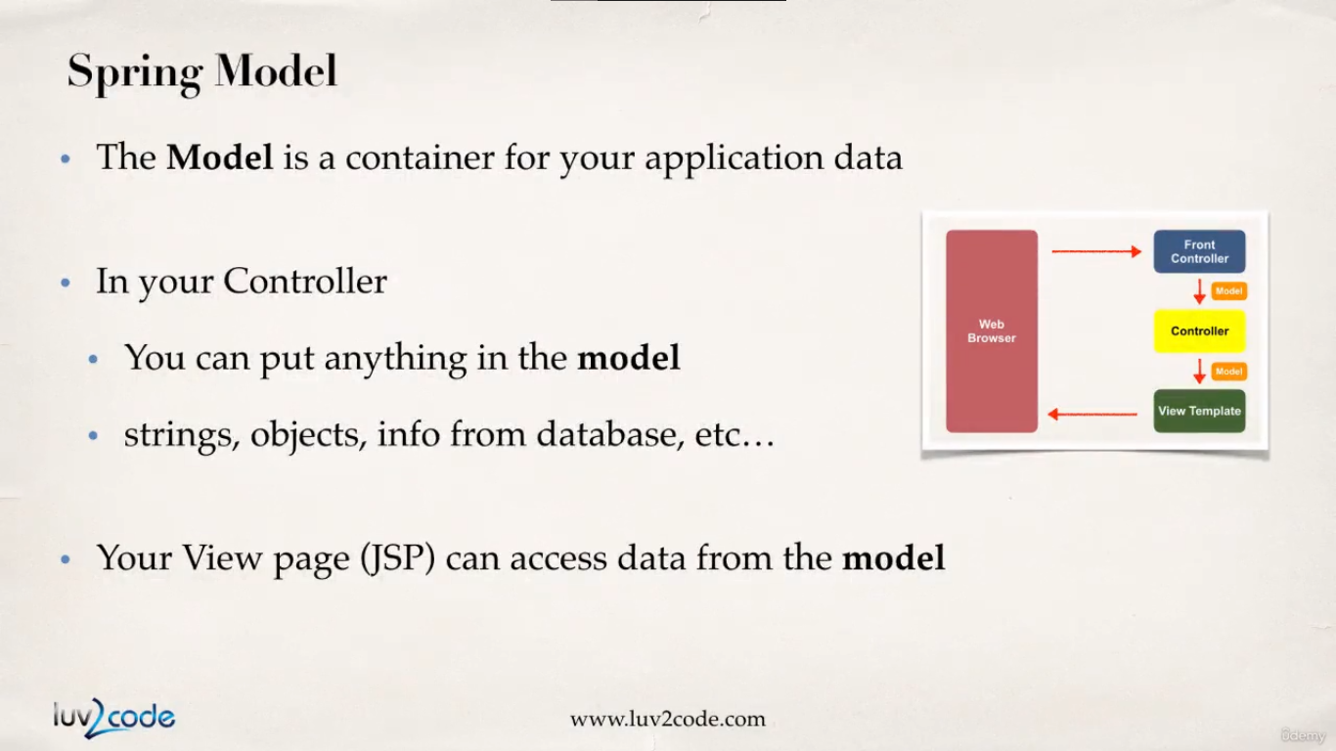

Well in the following coding examples we are going to do the following :

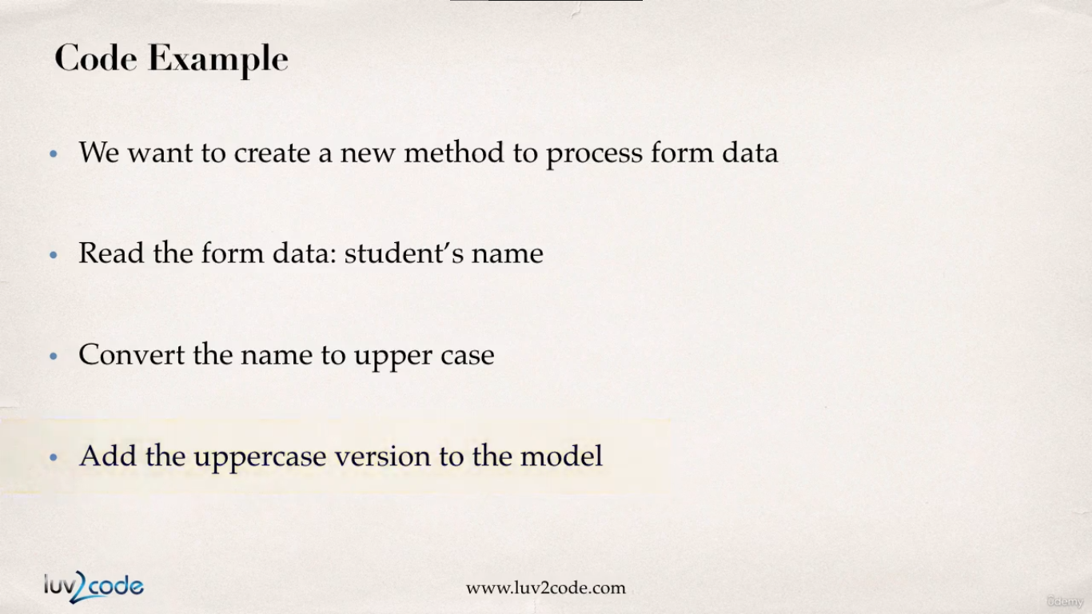

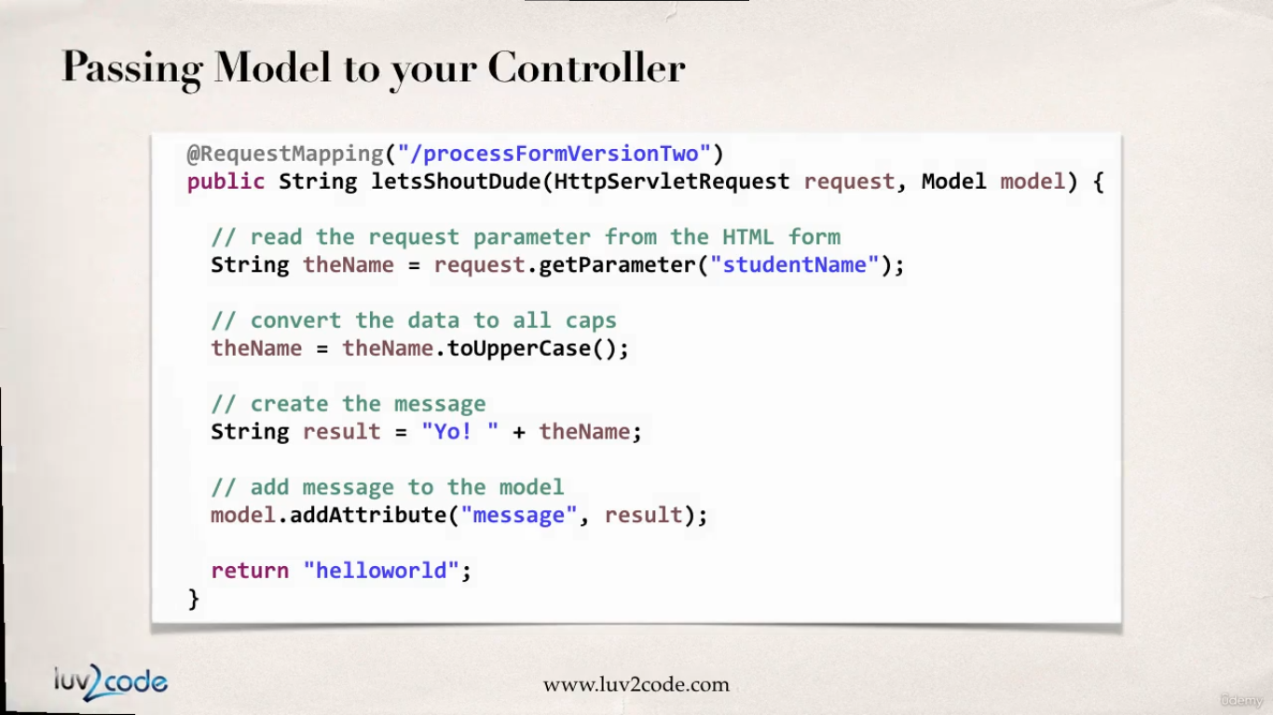

The controller methods are very flexible in terms of receiving arguments. We get the request object and the model object. Initially the model will be empty and as we go through our application we keep on adding data to the model which can be accessed from the JSP page as shown below.

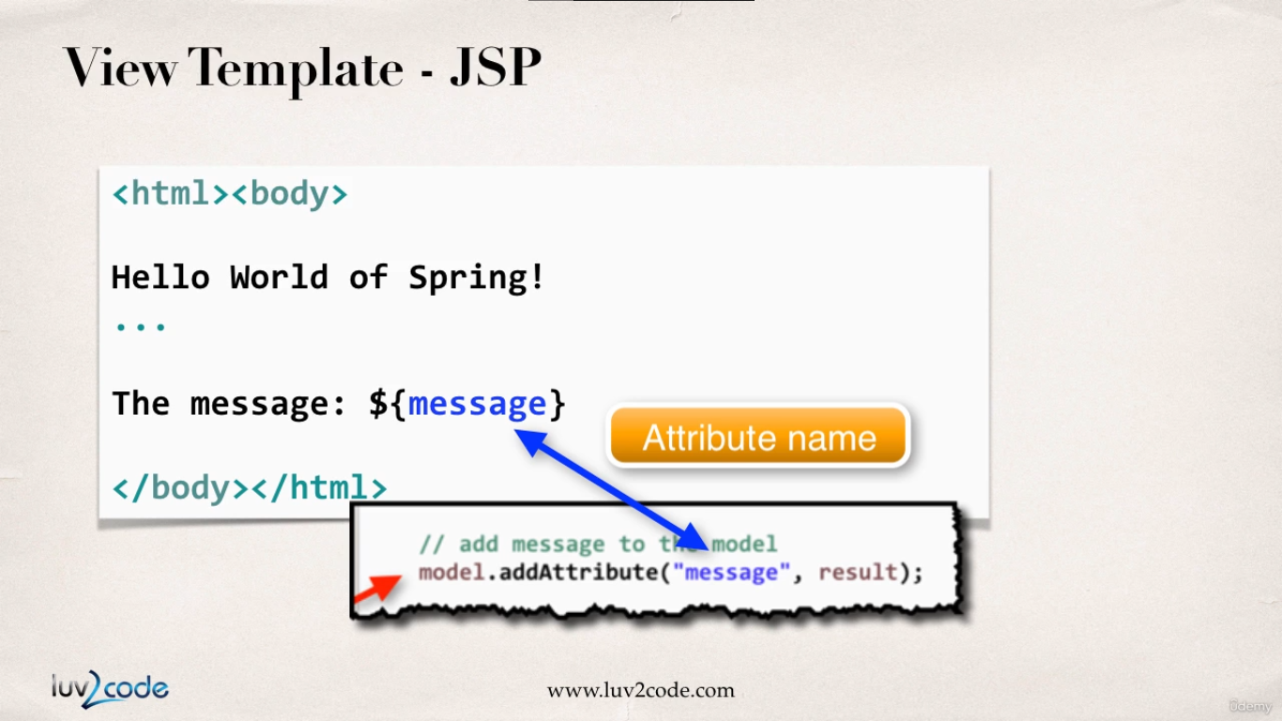

**HelloWorldController.java :**

**package** com.luv2code.springdemo.mvc;

**import** javax.servlet.http.HttpServletRequest;

**import** org.springframework.stereotype.Controller;

**import** org.springframework.ui.Model;

**import** org.springframework.web.bind.annotation.RequestMapping;

@Controller

**public** **class** HelloWorldController {

// create a controller method to show initial html form

@RequestMapping("/showForm")

**public** String showForm() {

**return** "helloworld-form"; // WEB-INF/view/hellowworld-form.jsp

}

// create a controller method to process the html form

@RequestMapping("/processForm")

**public** String processForm() {

**return** "helloworld";

}

// add a new controller method to read data from the form

// add data to the model

@RequestMapping("/processFormVersionTwo")

**public** String shoutOut(HttpServletRequest request, Model model) {

// read the request parameter from the HTML form

String studentName = request.getParameter("studentName");

// convert all data to upper case

String upperCaseName = studentName.toUpperCase();

// create our message

String message = "yo !! " + upperCaseName;

// add message to model data

model.addAttribute("message", message);

**return** "helloworld-version-two";

}

}

**Main-menu.jsp : (when user visits ‘/’ this page is displayed)**

<html>

<head>

<title>Spring MVC HOME Page</title>

</head>

<body>

<h1>Spring MVC HOME Page</h1>

<a href=*"showForm"*>show form page</a>

</body>

</html>

Output :

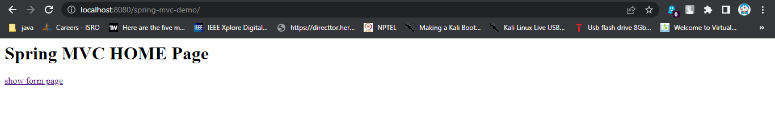

Now when user clicks on the link ‘showForm’ the **HelloWorldController** will render **helloworld-form.jsp**. Please look at the controller method for ‘showForm’ url mapping

**Helloworld-form.jsp :**

<!DOCTYPE html>

<html>

<head>

<meta charset=*"ISO-8859-1"*>

<title>Hello World - Input Form</title>

</head>

<body>

<form action=*"processFormVersionTwo"* method=*"get"*>

<input type=*"text"* name=*"studentName"* placeholder=*"what's your name"*>

<input type=*"submit"*>

</form>

</body>

</html>

Output :

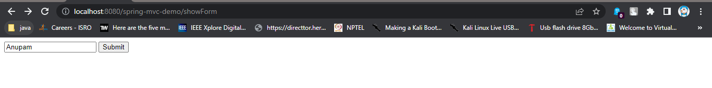

Now when user enters the value and hits submit we will load ‘processFormVersionTwo’ url path and the **HelloWorldController** will load **helloworld-version-two.jsp**. Please look at the controller method for ‘processFormVersionTwo’ url mapping

**Helloworld-version-two.jsp :**

<!DOCTYPE html>

<html>

<head>

<meta charset=*"ISO-8859-1"*>

<title>Hello World</title>

</head>

<body>

<h1>Hello World of Spring</h1>

<p>Student name is ${param.studentName}</p>

<p>The Message is ${message}</p>

</body>

</html>

Output :

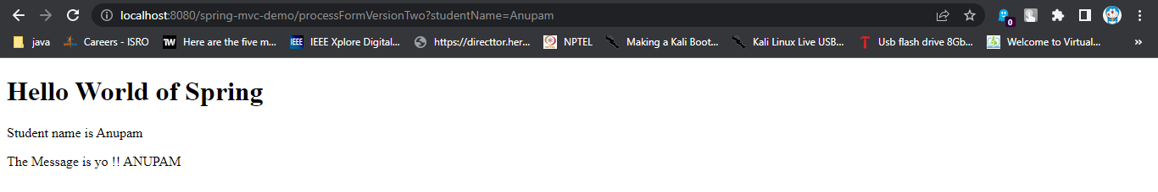

Reading Form Data with @RequestParam Annotation

Previously we read the form data from the incoming request using **HttpServletRequest** as shown in the image below :

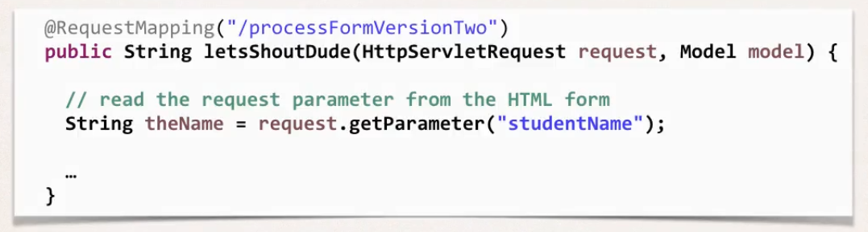

But now we will use the **@RequestParam** annotation which will get the data for us from the request object and the same data will be assigned to a method variable. This is shown in an image below :

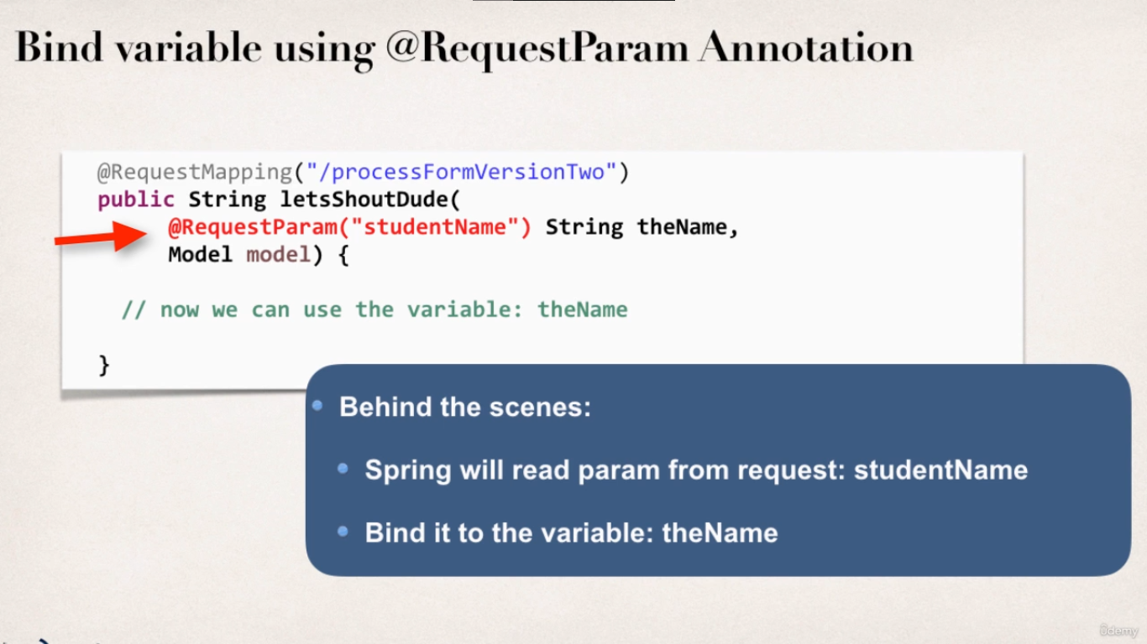

**HelloWorldController.java : ( with added @RequestParam(“__”) )**

**package** com.luv2code.springdemo.mvc;

**import** javax.servlet.http.HttpServletRequest;

**import** org.springframework.stereotype.Controller;

**import** org.springframework.ui.Model;

**import** org.springframework.web.bind.annotation.RequestMapping;

**import** org.springframework.web.bind.annotation.RequestParam;

@Controller

**public** **class** HelloWorldController {

// create a controller method to show initial html form

@RequestMapping("/showForm")

**public** String showForm() {

**return** "helloworld-form"; // WEB-INF/view/hellowworld-form.jsp

}

// create a controller method to process the html form

@RequestMapping("/processForm")

**public** String processForm() {

**return** "helloworld";

}

// add a new controller method to read data from the form

// add data to the model

@RequestMapping("/processFormVersionTwo")

**public** String shoutOut(HttpServletRequest request, Model model) {

// read the request parameter from the HTML form

String studentName = request.getParameter("studentName");

// convert all data to upper case

String upperCaseName = studentName.toUpperCase();

// create our message

String message = "yo !! " + upperCaseName;

// add message to model data

model.addAttribute("message", message);

**return** "helloworld-version-two";

}

@RequestMapping("/processFormVersionThree")

**public** String processFormMethodThree(@RequestParam("studentName") String studentName, Model model) {

// convert all data to upper case

String upperCaseName = studentName.toUpperCase();

// create our message

String message = "yo Buoy !! " + upperCaseName;

// add message to model data

model.addAttribute("message", message);

**return** "helloworld-version-two";

}

}

Output (only final page is shown):

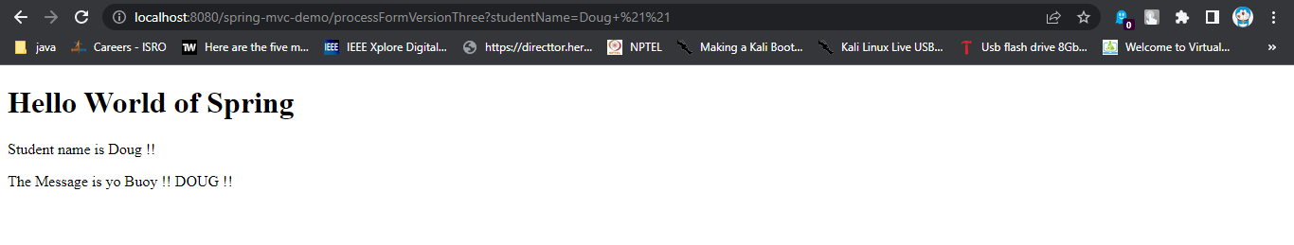

Spring MVC Form Tags

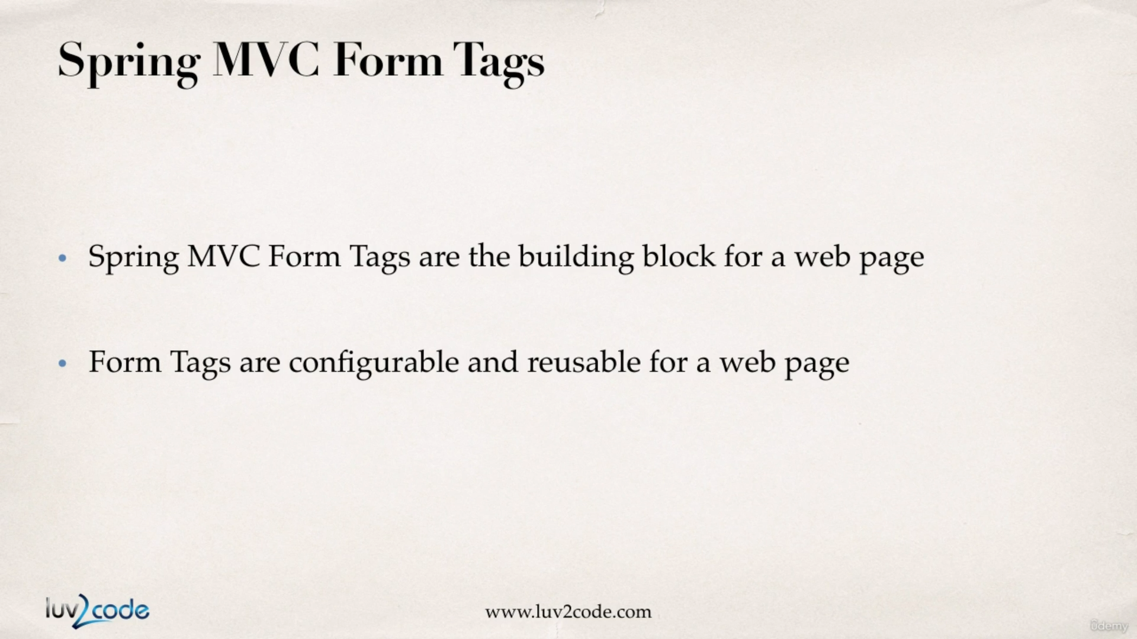

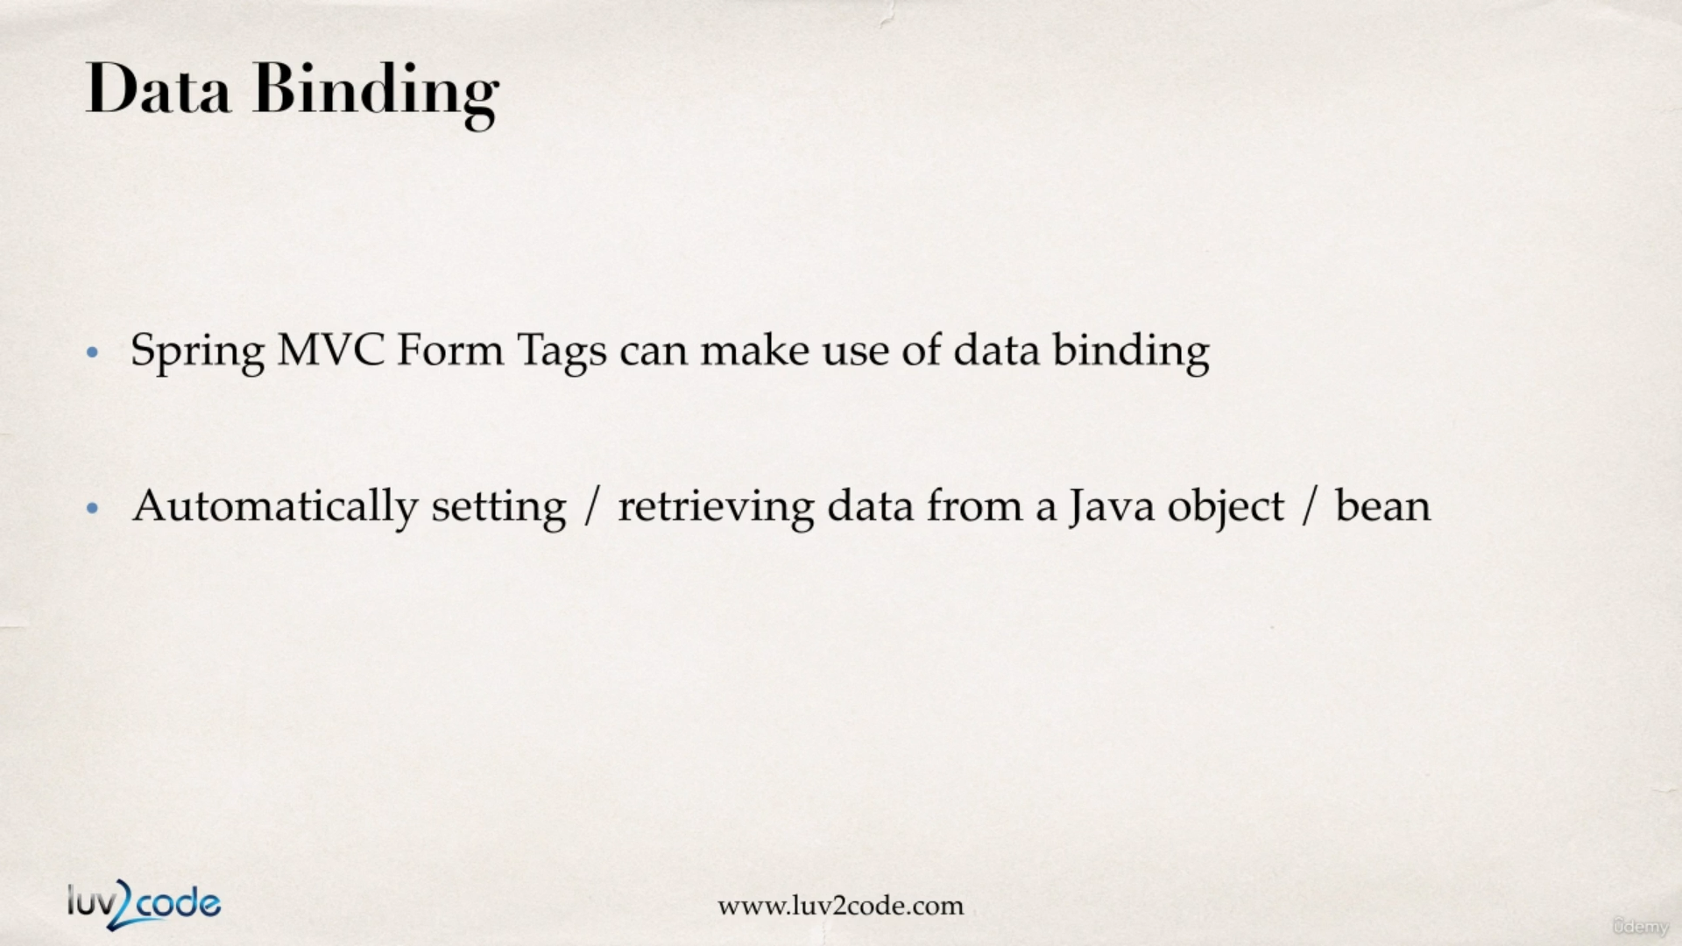

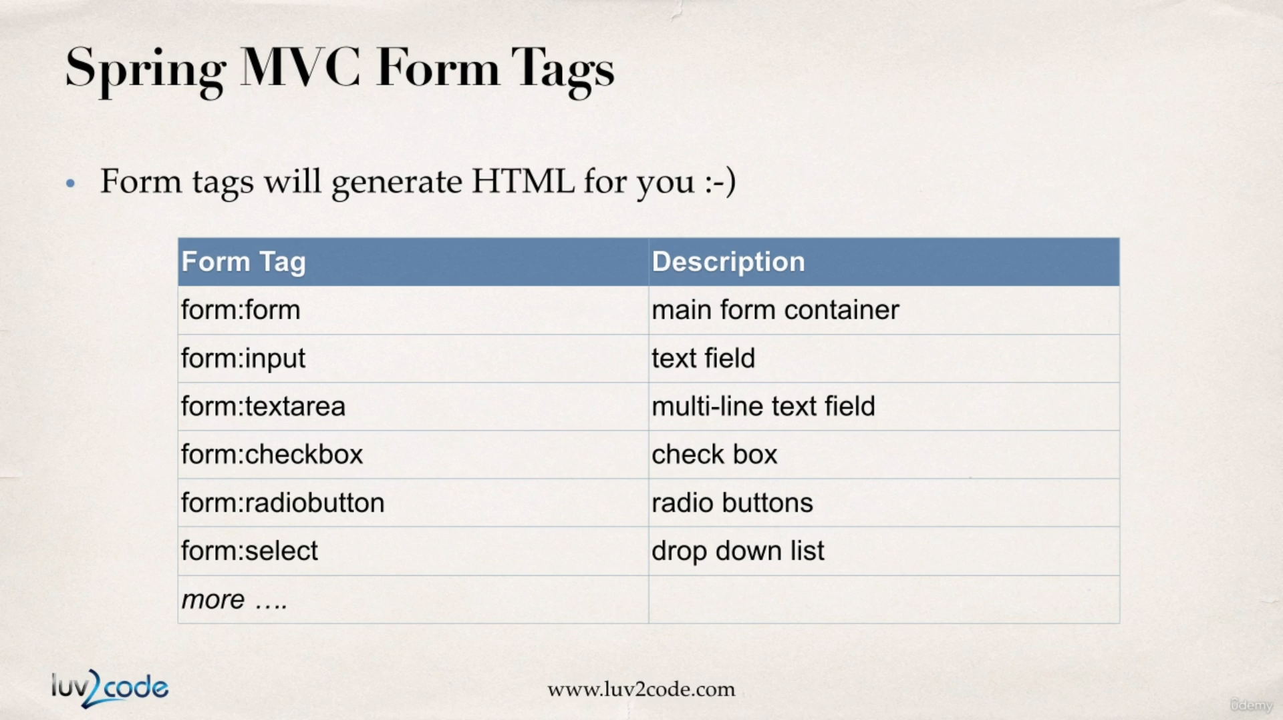

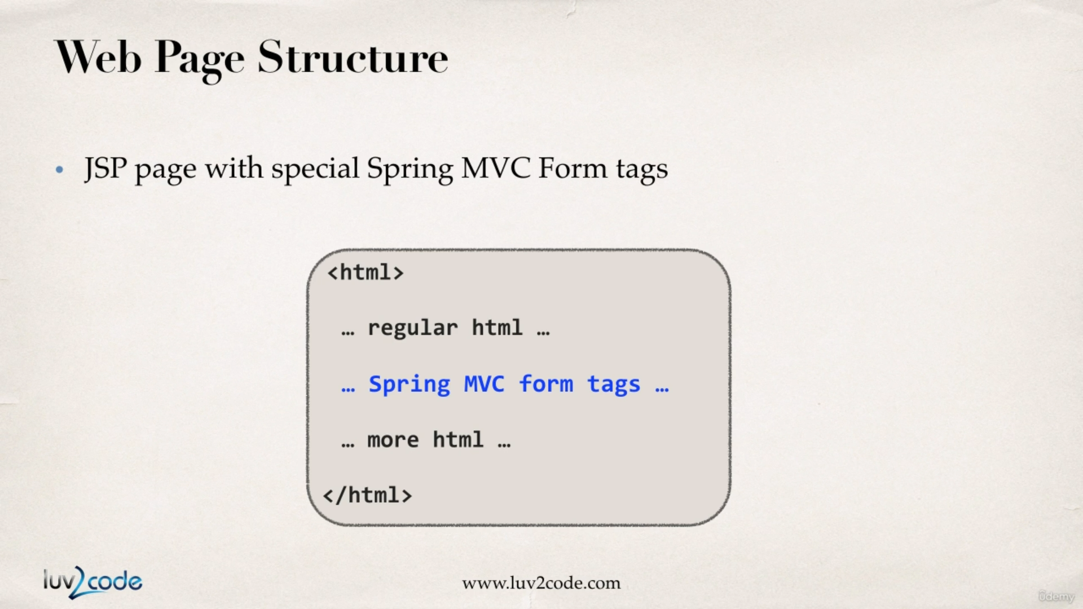

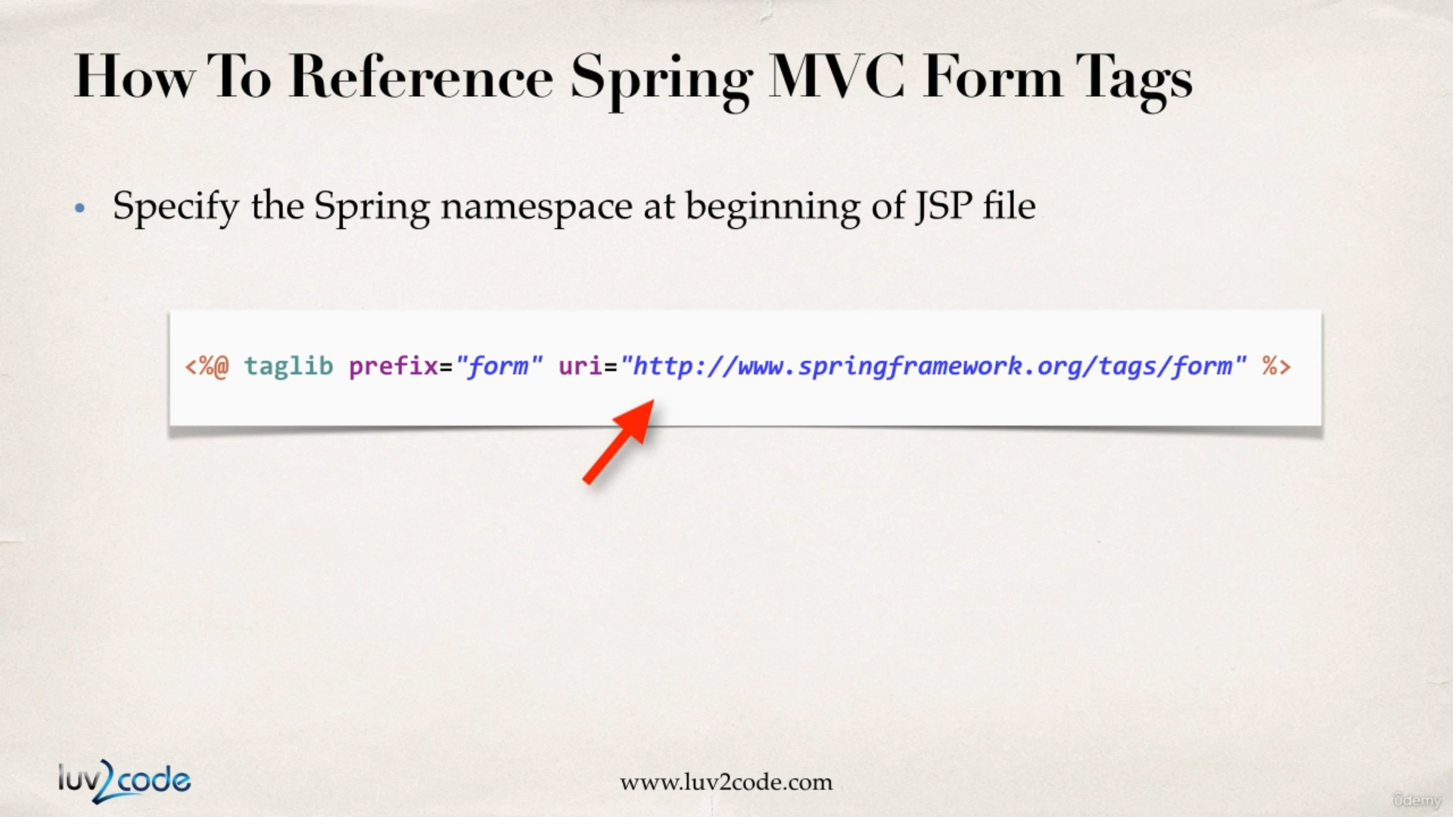

**Text Field**

In the following scenario we will code the scenario as shown below where a student will fill out the information and once he hits enter the request will hit the Student Controller (we will create this) and then we will show the data from the model into the JSP file.

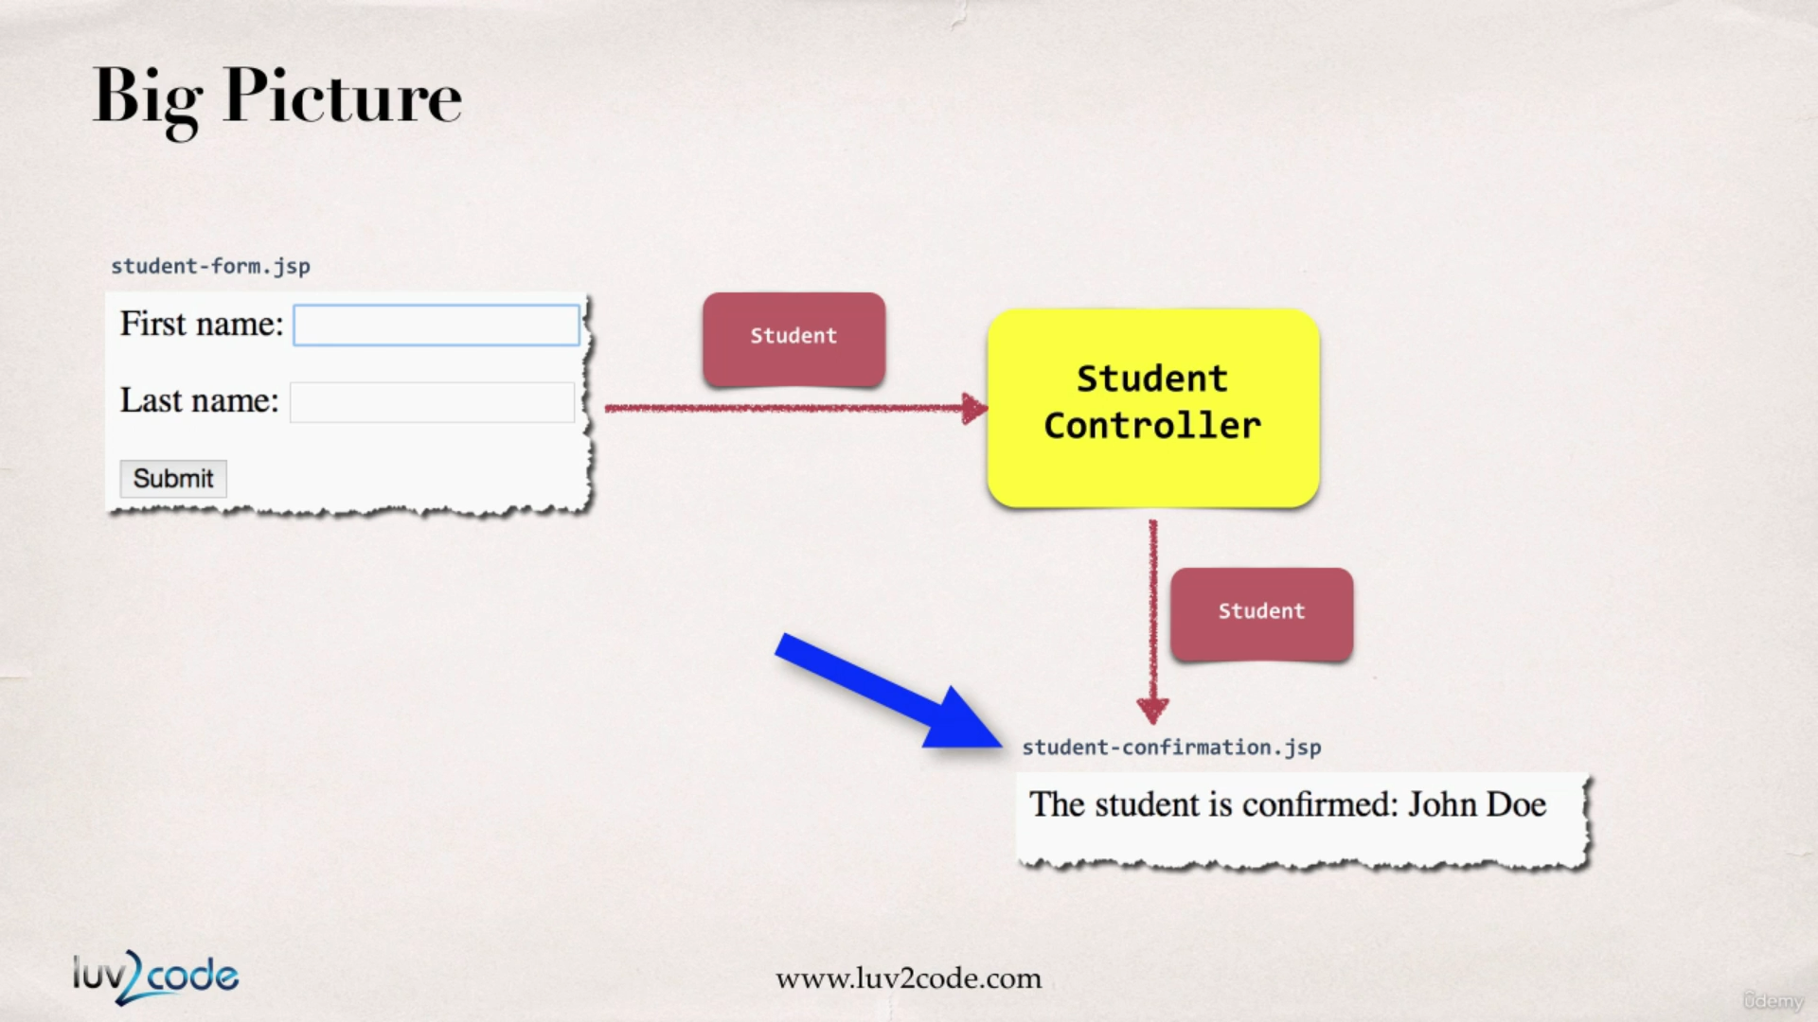

So, in our spring controller before we show the form we must add a model attribute, this is a bean that will hold the form data for the data binding.

Development Process for form:input demonstration :

1. Create a Student class
2. Create a StudentController class
3. Create HTML form
4. Create form processing code
5. Create confirmation page

**Student.java :**

**package** com.luv2code.springdemo.mvc;

**public** **class** Student {

**private** String firstName;

**private** String lastName;

**public** Student() {

}

**public** String getFirstName() {

**return** firstName;

}

**public** **void** setFirstName(String firstName) {

**this**.firstName = firstName;

}

**public** String getLastName() {

**return** lastName;

}

**public** **void** setLastName(String lastName) {

**this**.lastName = lastName;

}

}

**StudentController.java :**

**package** com.luv2code.springdemo.mvc;

**import** org.springframework.stereotype.Controller;

**import** org.springframework.ui.Model;

**import** org.springframework.web.bind.annotation.ModelAttribute;

**import** org.springframework.web.bind.annotation.RequestMapping;

@Controller

@RequestMapping("/student")

**public** **class** StudentController {

@RequestMapping("showForm")

**public** String showForm(Model model) {

// create a new Student object

Student student = **new** Student();

// add student object to the model

model.addAttribute("student", student);

**return** "student-form";

}

/**

* Now when we do a submit from the form, then this **@ModelAttribute** will grab

* the student object data and the same will be available for us inside the

* controller for further processing.

*

* **@param** student

* **@return** String

*/

@RequestMapping("processForm")

**public** String processForm(@ModelAttribute("student") Student student) {

// log the stuedent data

System.***out***.println("First Name : " + student.getFirstName());

System.***out***.println("Last Name : " + student.getLastName());

**return** "student-confirmation";

}

}

**student-form.jsp :**

<%@ taglib prefix=*"form"* uri=*"http://www.springframework.org/tags/form"*%>

<!DOCTYPE html>

<html>

<head>

<meta charset=*"ISO-8859-1"*>

<title>Student Registration</title>

</head>

<body>

<!-- modelAttribute is used to reference the Student model -->

<form:form action=*"processForm"* modelAttribute=*"student"*>

<!-- This path attribute is very vital role here.

This attribute is used to reference property in the student model object

So when the form is rendered spring will call student.getFirstName() for path="firstName"

and it will also call student.getLastName() for path="lastName"

So if we have some value inside the student object the form will load with

pre populated values.

-->

<!-- behind the scenes the student.getFirstName() is called -->

First Name : <form:input path=*"firstName"*/>

<!-- behind the scenes the student.getLastName() is called -->

Last Name : <form:input path=*"lastName"*/>

<!-- Now when we submit the form spring will call student.setFirstName(...) for path="firstName"

also it will call student.setLastName(...) for path="lastName" with this any value we

entered into the form fields will be bound to the model and will be accessible in the

controller method for further processing

-->

<input type=*"submit"* value=*"submit"*>

</form:form>

</body>

</html>

**student-confirmation.jsp :**

<!DOCTYPE html>

<html>

<head>

<meta charset=*"ISO-8859-1"*>

<title>Student Confirmation Page</title>

</head>

<body>

<!-- behind the scenes the student.getFirstName() is called -->

<!-- behind the scenes the student.getLastName() is called -->

Student is Confirmed : ${student.firstName} ${student.lastName}

</body>

</html>

**main-menu.jsp :**

<html>

<head>

<title>Spring MVC HOME Page</title>

</head>

<body>

<h1>Spring MVC HOME Page</h1>

<a href=*"showForm"*>show form page</a>

<a href=*"student/showForm"*>student form</a>

</body>

</html>

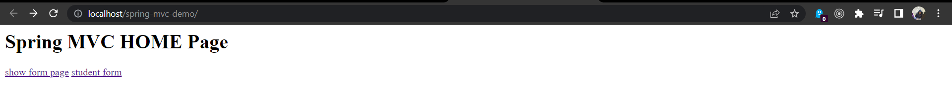

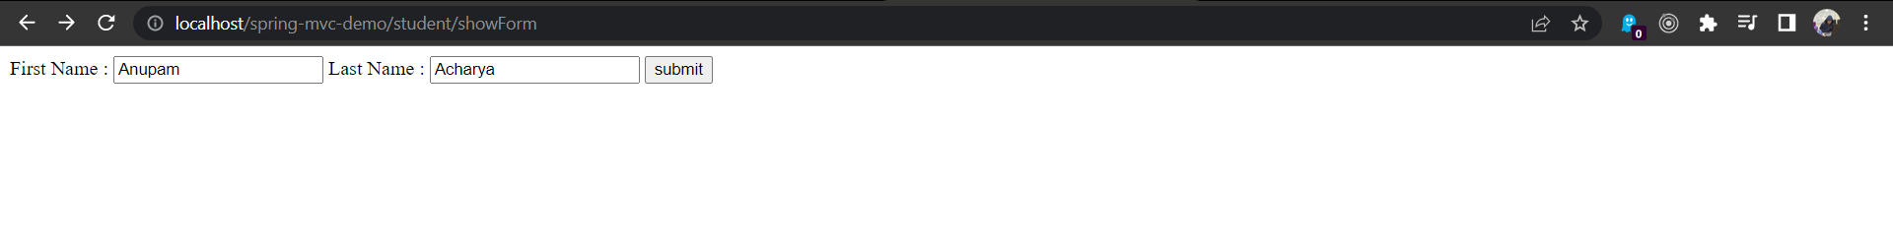



Spring MVC Form Tags : Drop Down List